 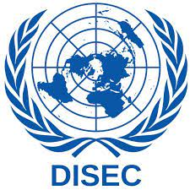

COUNTRY: People’s Republic of China

COMITTIE: Disarmament and International Security Commitie

TOPIC:

People's Republic of China extends its sincere appreciation for the warm reception in the Disarmament and International Security Committee. As we collectively navigate the challenges to global security, we eagerly anticipate productive collaboration with fellow nations. People's Republic of China reaffirms its unwavering commitment to preventing the use of chemical and biological weapons. Recognizing the severe global implications, we stress the critical need for stringent international oversight and cooperation to mitigate these threats to international peace and security.

The global community faces an ever-present threat from the potential use of chemical and biological weapons. People's Republic of China firmly condemns any such activities and actively supports robust international efforts aimed at countering these threats. Our commitment to a world free from these perilous weapons is resolute. People's Republic of China advocates for the following concrete steps to prevent the use of chemical and biological weapons: Strengthen collaboration through platforms for information exchange, joint research initiatives, and the sharing of best practices to enhance our collective understanding and response mechanisms. Enhance international inspection teams and monitoring mechanisms, ensuring transparency and accountability in facilities related to the production and storage of chemical and biological weapons. Recognizing the evolving nature of threats, bolstering cybersecurity measures is essential. Collaborative efforts to address potential cyber threats to critical infrastructure are paramount.

In conclusion, People's Republic of China believes that a comprehensive, cooperative, and multilateral approach is imperative to effectively address the prevention of chemical and biological weapons' use. We look forward to engaging in substantive discussions and collaborative efforts with all committee members.