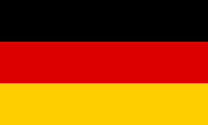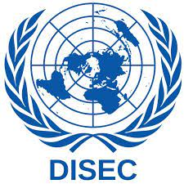Country: Germany

Commitie: Disarmament and International Security Commitie

Topic:

Germany has made efforts, nationally and internationally, to prevent the use and leakage of biological and chemical weapons and to take steps towards disarmament. In this regard, Germany, as an EU member, supports and contributes to the general policies of the European Union. Additionally, the Major Licensing Organization (NPT) plays an active role in international conventions such as the Biological and Chemical Weapons Convention (BWC) and the Chemical Weapons Convention (CWC).

Biological and chemical weapons are weapons that can be used to carry out very damaging attacks on humans, including damaging and destructive effects on human health and the environment. Therefore, preventing the use and sealing of such weapons is an important issue of international security. By continuing its work on this issue, Germany contributes to preventing the development, storage and use of such weapons.

As a member of the EU, Germany supports and contributes to the general policies of the EU. The EU continues its work on this issue and contributes to preventing the development, storage and use of such weapons. The EU supports and implements international agreements such as BWC and CWC. Germany continues its work on this issue and contributes to the implementation of these agreements. Disarmament is an important issue to prevent attacks against people and to help people after prevention. Germany continues its work on disarmament and contributes to taking steps in this regard. Germany supports and implements international agreements, including the issue of disarmament included in these agreements.

As a member of the EU, Germany supports and contributes to the general policies of the EU. The EU continues its work on disarmament and contributes to taking steps in this regard.