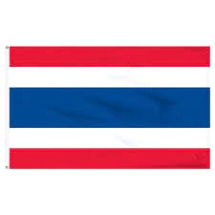THAILAND/DISEC
Thailand, like most countries, strongly opposes the use of biological weapons. The country is a signatory to the Biological Weapons Convention which prohibits the development, production, and stockpiling of biological and toxin weapons. Thailand views biological weapons as a serious threat to global health security and believes that their use would have devastating humanitarian consequences. The country advocates for strict adherence to the BWC and actively participates in international efforts to prevent the proliferation of biological weapons. Thailand emphasizes the importance of cooperation among nations to ensure that biological weapons are never used again.
Thailand is not known to possess or be actively developing biological weapons. Thailand is a member state of the Biological Weapons Convention which is an international treaty that prohibits the development, production, and stockpiling of biological weapons. Thailand has also taken steps to enhance its public health infrastructure and response capabilities, particularly after experiencing outbreaks of infectious diseases such as SARS and H5N1 avian influenza. However, it's always advisable to consult the latest sources or official statements for the most up-to-date information on this topic.
Thailand has been a member of the Biological Weapons Convention since 1972, demonstrating its commitment to prohibiting the development, production, and stockpiling of biological weapons. The country has consistently supported disarmament efforts and has taken steps to enhance its public health infrastructure and response capabilities. Thailand's position on biological weapons aligns with its broader foreign policy goals of promoting peace, security, and cooperation in the region and beyond. The country's history with biological weapons is marked by a commitment to disarmament and non-proliferation, reflecting its stance as a responsible member of the international community.

