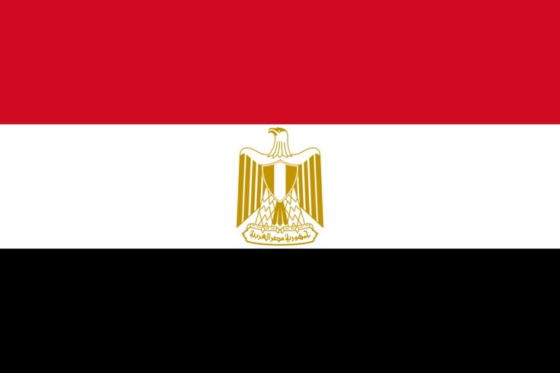

Conference: MUNAAS’24

Committee: UNESCO

Country: Egypt

Topic: Preserving Cultural Heritage

Egypt, a nation with a rich and diverse cultural heritage, recognizes the importance of preserving historical treasures. As a member of UNESCO, Egypt is committed to collaborating on initiatives that safeguard and promote its unique cultural legacy.

Egypt’s cultural heritage includes long years, some iconic structures like the Pyramids of Giza and the Sphinx, along with priceless artifacts from ancient ages. UNESCO plays a vital role in assisting Egypt to preserve these treasures for future generations.

Despite efforts, Egypt faces challenges such as environmental factors, urbanization, and illicit trafficking of cultural artifacts. UNESCO’s support is essential in addressing these issues and apply effective strategies for preservation.

Egypt calls upon UNESCO to strengthen efforts in providing technical assistance, capacity building, and financial support. Collaborative initiatives can empower local communities, enhancing their role in safeguarding and transmitting cultural knowledge.

Promoting cultural education is really important to preservation. Egypt encourages UNESCO to speed up educational programs, fostering awareness and appreciation among citizens, especially the youth, to instill a sense of responsibility for their heritage.

Preserving Egypt’s cultural heritage requires international cooperation. Egypt seeks UNESCO’s assistance in encouraging collaboration between member states, sharing expertise and creating a united front against the illicit trade of cultural artifacts.

In conclusion, Egypt emphasizes the main role of UNESCO in preserving its rich cultural heritage. By developing collaboration and promoting educational initiatives, we can ensure that Egypt’s treasures endure as a source of inspiration and knowledge for generations to come.