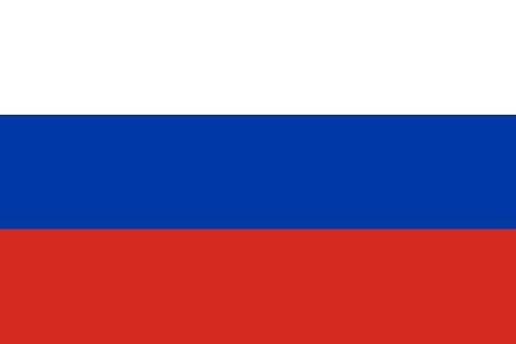

Country: Russian Federation

Committee: Disarmament and International Security Committee

Topic: Chemical and Biological Weapons

Chemical and biological weapons create a serious threat to international peace and security, which concerns the Russian Federation greatly. We firmly believe the Convention on Chemical Weapons and the Convention on Biological Weapons provide crucial foundations for stopping the spread of these weapons.   
  
In order to increase confidence, we encourage all states to fully fulfill their commitments under these accords and to strengthen their transparency policies. It is essential to address the underlying factors that accelerate the spread of chemical and biological weapons.   
  
In order to eradicate chemical and biological weapons and make the world a safer place for everyone, the Russian Federation is still dedicated to collaborating with all of its members.

Thank you.