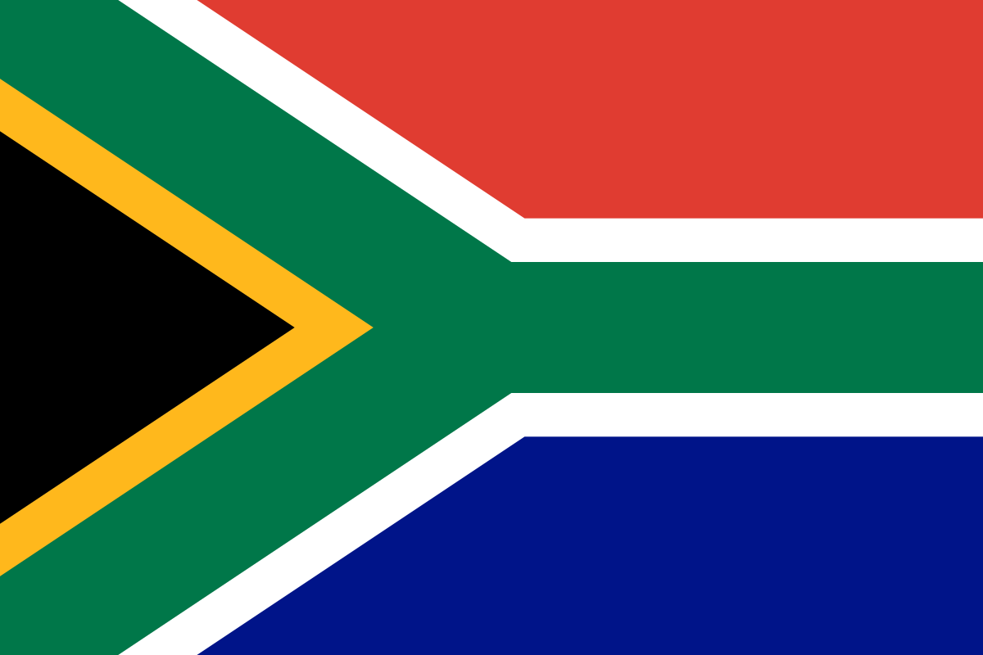**Committee:** DISEC

**Country:** South Africa

**Agenda Item(s):** Prohibition of Chemical and Biological Weapons

South Africa, officially the Republic of South Africa, is the southernmost country in Africa, neighboring countries of Namibia, Botswana, Zimbabwe, Mozambiquex and Lesotho. It covers over 1,221,037 square kilometers of land with coastlines on both the South Atlantic and Indian Oceans. With a population of over 62 million people from diverse cultures, South Africa was first colonized by the Portuguese, Dutch, and British, gaining independence on May 31, 1910. Today, South Africa is a biodiversity hotspot, boasting over 12 different languages spoken and unique biomes, plants, animal life, and a plethora of cultures. It has the most industrialized and technologically advanced economy in Africa, ranking as the 39th largest economy globally, with a GDP of over $330 billion USD. South Africa is the second most populous country located entirely south of the equator and has been a member of the United Nations since 1945.

Chemical warfare is a horrifying method of conflict, resulting in agonizing deaths. Whether delivered by artillery shells or dispersed through planes contaminating vital resources, chemical and biological weapons have inflicted suffering across diverse landscapes, from the depths of Vietnam's forests to Flanders Fields in Belgium. Despite the Geneva Convention's prohibition of asphyxiating, bacteriological, and poisonous warfare, which marked the first international treaty addressing chemical and biological warfare, there were significant shortcomings in verification and enforcement. In 1972, the Biological Weapons Convention (BWC) was opened for signature, entering into force in 1975. The BWC succeeded the Geneva Convention, specifically targeting biological weapons, outlawing their creation, production, purchase, transfer, storage, and usage. It became the first international law to entirely prohibit a class of Weapons of Mass Destruction (WMD). Following the BWC, the Chemical Weapons Convention (CWC) was established in 1993, aiming to prohibit the development, production, storage, retention, transfer, or use of chemical weapons by State Parties. South Africa ratified the BWC in 1975 and the CWC in 1995, demonstrating its commitment to complying with the provisions of these treaties, including the destruction of its chemical weapons stockpiles and implementing measures to prevent the proliferation of biological weapons-related materials and technology.

Despite the existence of these conventions and laws, the use of chemical and biological weapons persists. To address this issue comprehensively, we propose the following measures:

Strengthen Currently Existing Treaties: Continuously reinforce and enforce existing treaties such as the BWC and CWC to ensure their effectiveness.

Embargo, Diplomatic Pressure, and Sanctions: The international community can impose sanctions and penalties on countries found to be in violation of CBW treaties. These measures can include economic sanctions, diplomatic isolation, and other actions to deter the violation of CBW treaties.

Enhanced Monitoring and Verification Mechanisms: Improving already existing monitoring and verification would ensure compliance with CBW and BWC treaties. This could include advanced surveillance to detect any illegal activities.

By implementing these measures, we can work towards effectively prohibiting the use of chemical and biological weapons, safeguarding global security and peace.