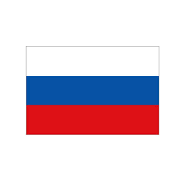

**Country:** Russian Federation

**Committee:** Disarmament and International Security Committee

**Agenda Item**: Nuclear Non-proliferation and Disarmament

Honorable chairs and fellow delegates,

Russia’s role is to help other countries about nuclear weapons and other weapons as Russia is a big and strong country.As a part of this commitee Russia is responsible for disarmament to maintain security and peace

As Russia, we are trying to place an impact on non-proliferation programs as it is starting to get dangerous.

And the production of electricity from nuclear power plants are widely seen today as having an increasing role.

The ENS HSC considers that manifestation of some strong countries needs to join those non-proliferation programs and Russia, as well

Russia is fully aware of the war going on in middle east, therefore, The world community must pay more attencion to nuclear weapons and nuclear power since the technology is getting more and more advanced also Russian people don’t want any kind of nuclear industrialization and war

Last but not least, communities need to educate people across the globe to create more attention to proliferation because education is a crucial step and we believe that within the light of this conference, we will be discussing possible solutions.

Thank you.