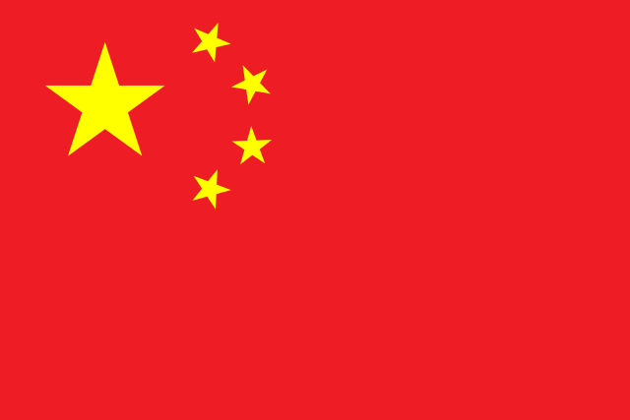

Country:China

**Country:** China

**Committee:**UNICEF

**Agenda Item:**Combating Malnutrition among Children in Undeserved Region

As a member state of the United Nations China recognizes the importance of international cooperation in addressing the challenges faced by children worldwide. The United Nations Children's Fund (UNICEF) plays a an important role in safeguarding the rights and well-being of children globally. This paper outlines China's stance on UNICEF's mission, its contributions to UNICEF, and the rights and welfare of children worldwide.

China reaffirms its strong support for UNICEF's mandate to promote and protect the rights of children. China recognizes UNICEF's efforts in areas such as education, health, nutrition, child protection, and emergency response. China acknowledges the importance of multilateralism in addressing global challenges, including those affecting children, and is committed to working closely with UNICEF and other relevant stakeholders to achieve shared goals.

China is committed to fulfilling its international obligations and actively contributes to UNICEF's work through various channels, including financial support, technical expertise, and partnership building. China has provided significant financial contributions to UNICEF's programs and projects, particularly in areas such as education, health, and nutrition. Additionally, China has shared its experiences and best practices in areas such as poverty ,child health, and early childhood development with other countries through South-North cooperation and other mechanisms.

China has made significant progress in advancing children's rights domestically, including efforts to improve access to education, healthcare, and social protection for all children, especially those from marginalized and vulnerable groups. China is committed to continuing its efforts to address remaining challenges and strengthen its child protection system to ensure the well-being and development of every child.

In conclusion, China reaffirms its strong support for UNICEF's mission and its commitment to promoting and protecting the rights and welfare of children worldwide, China aims to contribute meaningfully to UNICEF's efforts to build a better world for every child.