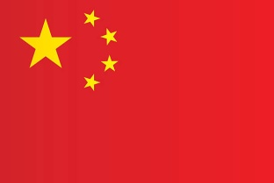

**Committee** : United Nations Women  
**Country**: Republic of China  
**Agenda item:** Empowerment of Women  
  
The People's Republic of China is one of the oldest civilizations in the world. China is the third largest country in the world, located west of the Pacific Ocean and east of the Asian continent. Its capital is Beijing and its largest city is Shanghai. China, a technological and economic development region, has trade links with more than 220 countries. Our main sources of livelihood; Agriculture, Forestry, Livestock, Fishing and Trade. Our country also attaches great importance to education. Our primary school participation rate is 99%. We are aware that many problems in society, especially gender inequality, stem from lack of education.  
As the People's Republic of China, no matter how much importance we attach to education, gender inequality cannot be prevented as in all nations. But this should not lead us to despair, on the contrary, it should encourage us to work harder and create projects for a world where women and men have more equal rights. Sadly, this gender inequality in society leads to gender-based violence and even femicide. Gender-based violence is inhumane behavior. One out of every three women is subjected to violence. Since not all women who experience violence report these crimes, we can assume that the figures will be higher. We need to raise women's awareness about their rights and the right to make decisions about their own bodies.Women should have access to basic rights such as education, health and employment. This also accelerates the economic and social development of society. Increased participation of women in the labor force increases productivity and economic growth.  
Our country is working for gender equality and raising awareness of women about their rights. We need to increase efforts to ensure that women have easier access to rights such as education, health and employment. We need to pass new laws on education, health, labor, violence and homicide. We must join hands to work with civil society. Creating gender inequality movements that can work in all countries should be one of our Sustainable Development Goals. This is also what we expect from the UN.

**References:**

[www.digitalibrary.com](http://www.digitalibrary.com)

[www.cia.gov.tr](http://www.cia.gov.tr)

[www.un.org](http://www.un.org)