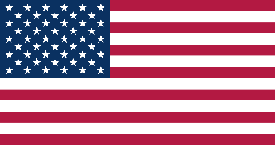

**Country:** TheUSA

**Commitee:**UN WOMEN

**Agenda Item:** Empowerment of Women

Today, there are countries that do not value women's rights. The USA wants to show the power of women by taking measures to protect women's rights in America and alerting the world to this issue. Half of the world's population is made up of women and girls and if we want to tackle other world problems, we must pay attention to women's rights and warn those who do not pay attention to women's rights. Women should have the same rights as men and it is especially important that women have the right to choose who governs them.

The world is currently confronting numerous challenges posed by the largest flow of forced migration since the Second World War. The USA is fully aware of the difficult situation for all migrants, but especially for women and other minority groups.The number of hardships experienced by women during the Secound World War is enormous. Women are at risk of violence, trafficking, exploitation and sexual assault, abuse and discrimination in their home countries and for this reason women should also learn to protect themselves and not depend on men for this. Susan B. Anthony emphasized this point when she said: "women should not depend on men for protection, they should learn to protect themselves." Susan B. Anthony was a woman who fought hard for women's rights in America. She is just one of the pioneers in defense of women's rights. Here in the United States, we are working to warn countries that do not value women’s rights and to make sure that women’s voices are heard.

It is also way to meet international commitments in to promote development and humans rights. Moreover empowering women also improves the lives of everyone women,men,families and whole communities.If we want to solve the world problems like these, we need to work together as women, children and men.

Thank you.

**References:**

<https://www.dianova.org>

<https://tr.m.wikipedia.org>