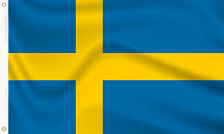

**Country:** Sweden

**Committee:** United Nations Children’s Fund

**Agenda Item:** Combating Malnutrition Among Children in Underserved Regions

**Sweden** is a country in the north of Europe. It shares borders with [Norway](https://www.twinkl.com.tr/teaching-wiki/norway)and **Finland**, and is also connected by a bridge across the water to **Denmark**. Sweden’s official name is the Kingdom of Sweden. It’s a constitutional monarchy, which means it has a king, all the political power exists in the parliamentary system.

As you know, Malnutrition is a significant problem in today’s world. Especially in some African countries, people have difficulties in having healthy earing habits.With less developed countries,

Sweden is fully aware of malnutrition among children and recommends the following precautions

Sweden can support breastfeeding and adding vitamins and minerals to basic foods.

Sweden also suggests that introducing regulations to prevent the sale of foods with lowe nutrition value in school canteens.

In addition, Sweden supports that restrictions on fast food chains to offer higher nutritional value products.

We fully hope to prevent the sale of harmful foods to all age groups

Goverment should also provide loans and funds to farmers to support agriculture and animal husbandry. Last but not least, it should be compulsory for factories to install treatment plants to prevent their dirty waste water from being dumped into clean water sources.