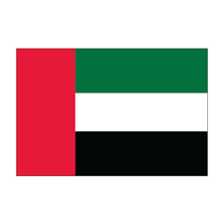

**Country**: United Arab Emirates

**Committee:** United Nations Development Programme

**Agenda Item:** Climate Crisis Adaptation and Resilience

The current population of United Arab Emirates in 2024 is 9,591,853(nine million five hundred and ninety one thousand eight hundred and fifty three). United Arab Emirates' neighbors are Saudi Arabia and umman. it is also 83,600 km² in size. Summers are long, stifling hot, flat, dry and partly cloudy and winters are comfortable, dry and partly cloudy. If we don’t stop climate change it will get worse. The UAE is also the first country in the region to commit to net zero carbon emissions by 2050. It has launched a hydrogen initiative, is planting 100 million mangrove trees, and hosted  [COP28](https://sdg.iisd.org/events/2022-un-climate-change-conference-unfccc-cop-28/) in Abu Dhabi in 2023.

United Arab Emirates believe that everyone can help limit climate change. From the way we travel, to the electricity we use and the food we eat, we can make a difference. Let’s start with these actions to help tackle the climate crisis.

Speak up and get others to join in taking action. It's one of the quickest and most effective ways to make a difference. Talk to your neighbors, colleagues, friends, and family. Let business owners know you support bold changes – from plastics-free products and packaging to zero-emissions vehicles. Appeal to local and world leaders to act now. Climate action is a task for all of us. And it concerns all of us. No one can do it all alone – but we can do it together..

Thank you.

**References:**

https://www.un.org/en/actnow/ten-actions