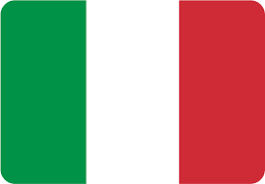

**Country:** Italy

**Committee:** European Council

**Agenda Item:** Refugee problem in Europe

Italy is located in South Europe and the Italian Peninsula. Italy’s capital is Rome and its language is Italian. The population of Italy is 59 million and its currency is Euro. Italy's income sources include farming, industry and the service sector.  
  
 The reason of the refugee problem in Europe is the Syrian War, because in this war, people in Syria went to different countries as refugees, including Italy. In this war, which has been going on for about 10 years, almost 6 million people have become refugees in Syria, and most refugees have settled in European countries or neighboring countries.  
  
Since Italy is a peninsula, most of the immigrants who reached the country came by sea, and the number of immigrants who reached Italy by sea this year is more than 127 thousand. Currently, there are nearly 6 million immigrants in Italy and the rate of this number to the total population is 2.5. Italy has made huge expenses to these problems. For example, in 2017, when 119 thousand immigrants arrived, Italy spent 2.7 billion Euros for expenses such as admission procedures.

Thank you for your attention.