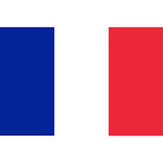

**Committee**: Sochum

**Country:** France

**Topic:** Enhancing Access to Educational Opportunites for Children Globally

It is a country located in Western Europe and has overseas territories in many parts of the world France population is 68 million.

As a developed country, France has contributed to children and their education. France fully supports public equality and children's rights. He provides a lot of aid for children's education and especially for children in poverty.

Since France is already a big donor, it does not spare its support.

Financial support and scholarship programs: scholarships, various scholarships and financial aid are provided for low-income families, examples of which are:

"family assistance" (allocations familiales): especially financial support, is provided to families order to alleviate education cost.

Free school supplies and supplies:

Free or reduced-price lunches are provided for children in need. At the same time, support programs are created for the purchase of school supplies.

What's Done at the International Level:

1. Cooperation with UNESCO:

• France works to increase access to education worldwide by contributing to UNESCO projects.

2. International Aid Programs:

• French Development Agency (AFD): Finances education projects to increase schooling rates in Africa and other developing regions.

3. Global Partnership for Education (GPE):

• France aims to improve the educational infrastructure in poor countries by providing financial support to initiatives such as GPE.

4. Organization of Francophonie (OIF):

• It carries out projects to improve the quality of education and training in French-speaking countries.

These initiatives of France aim to ensure equality in access to education and reduce children's exposure to social injustices.

**References:**

<https://www.un.org/en/ga/third/>

<https://imuna.org/nhsmun/nyc/committees/sochum-social-humanitarian-cultural-committee/>

<https://en.wikipedia.org/wiki/United_Nations_General_Assembly_Third_Committee>