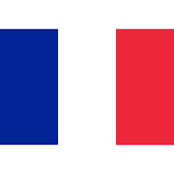

**Country:** France

**Comitee:** UNFCCC

**Agenda İtem:**Increaising the use of Renewable Energy Sources in Developing Countries

 France is the largest country in Western Europe, has long been a gateway between the continent's northern and southern regions. . France capital is Paris and  the population of France is :67,364,357.  It has a strong economy , with industries like technology, tourism, and agriculture. And also France has a mixed economic system which includes a variety of private freedom, combined with centralized economic planning and government regulation. Besides these France is also a leader in renewable energy, using nuclear power, hydropower, and wind energy.

France’s location and geography make it imporant in the fight against climate change. The country is a member of European Union. And they support other contries in solving climate problems. France believes in sustainable development and is active in global issues.

Many developing countries face big challenges due to climate change. These countries often use fossil fuels, which cause pollution and give harm to environment. Because of the problems caused by  non-renewable energy usage, they need better access to clean and cheap energy, like solar, wind and geothermal energy. Countries like China, India, and international organizations such as the UNFCCC and the Green Climate Fund are working on this issue. Reigons like Africa and Southeast Asia have great potential for renewable energy but they are economically, technologically and educationally inadequate. France has a long history of supporting developing countries, especially in Africa because of historical and cultural connections

 France wants to help developing countries use more renewable energy. It believes this will reduce pollution and improve living conditions. France will help to international funds like Green Climate Fund by giving more money. France wants to share knowledge about renewable energy by suggesting building training centers for teaching people how to use and manage renewable energy technologies. France will work with groups like the African Renewable Energy Initiative (AREI) to make sure that all efforts are well-organized and effective.

 France believes that all countries should work together to help developing nations.with this, the World can fight climate change and creat a better future for everyone.

France is ready to cooperate with all members of the UNFCCC to find solutions.

 Bibliography:

<https://globaledge.msu.edu/>