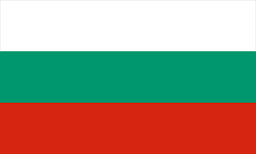

**Delegation:** Bulgaria

**Committee:** Disec

**Topic:** The Russia- Ukraine War and the Use of Weapons in International Law

The conflict in the Ukraine and Russia has raised worries that international law rules will be violated, including weapons and attacks on civilians by the occupying party. This paper identifies the main legal frameworks and the actions of Bulgaria in the context of the conflict as well.

Geneva Conventions: Official documents that protect civilians and define the regime of harmful weapons.

UN Charter: Asserts that an act of aggression towards a state`s sovereignty is criminal.

Arms Control Treaties: Condemn weapons such as chemical and cluster bombs that destroy the environment and agricultural land.

**Violations in the Conflict**

**Russia**: Accused of killing civilians in a targeted bombing and of using weapons.

**Ukraine:** Defenders` actions must be in line with the international humanitarian law.

**Bulgaria’s Role**

Humanitarian Aid: Implemented assistance for Ukrainian refugees.

EU Sanctions: Canada and other members imposed economic sanctions on Russia.

Military Assistance: Provided some military and all non-lethal assistance to Ukraine.

Diplomatic Efforts: Agreed with peace talks and the fact that nations must be held accountable for any wrongdoings.

Energy Independence:Weaned off the import of Russian fossil fuels.

Bulgaria has effectively taken steps to support Ukraine and maintain international law. International solidarity continues to be of utmost importance for justice and peace.

**References:**

<https://www.un.org/en/ga/first/>

<https://imuna.org/nhsmun/nyc/committees/disec-disarmament-international-security-committee/>