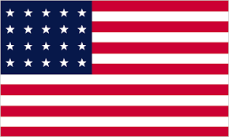

**Country:** The United States of America

**Topic:** Ensuring Equal Rights for Individuals with Disabilities in Education and Social Life

**Committee:** UNHCR

The USA is located in the northern hemisphere and covers an area of 24,230,000 km². The USA is one of the world's largest trading countries and one of the world's largest manufacturers. It is the world's largest natural gas and oil producer. The economy of the USA is more developed and stronger than most countries.  
  
A refugee agreement was made between the USA and Honduras. Honduras, a Central American country, requires refugees coming to the USA to first apply to Honduras and then to the USA. In this way, more refugees can find a country to seek asylum. During the Joe Biden era, we took 4 times more refugees into our country than during the Trump era. Biden made the following assessment on this issue: "The 15,000 quota, which was historically the lowest, did not reflect the fact that America, as a nation, accepts and supports refugees."  
  
We suppose that the United Nations should first establish shelters for refugees. It should also identify the needs of disabled refugees and then provide them with these needs.

Secondly, the health and education of refugees should be considered. For their health, more health workers and more hospitals should be opened. For their education, they first need to have a settled lifestyle. If the country they were born in becomes more innovative and democratic, maybe refugees will not have to migrate.

Thirdly, countries need to make agreements with each other to meet the basic needs of refugees and increase the number of civil society organizations for the basic rights of refugees.  
  
Thank you

**References:**

<https://www.unhcr.org/>

<http://www.wikipedia.org>