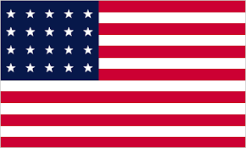

**Committee:**Sochum

**Delegation:** TheUnited States of America

**Topic:**Increasing children's global access to education

As the United States of America, we came here to protect our country, to defend our rights, and we believe that we will do what is best for our country.

The goals of global education are to promote understanding of different cultures and to integrate the role of people as dynamic actors for a more just and equal world, and to realize and attitudes that enable constructive non-violent solutions to work, no one can be deprived of the right to education and training (Article 42 of the Constitution) is not complied with. 244 billion children and about 2 millionchildren in the USA cannot go to school. Among the measures that can be taken against this are:

1. Expanding pre-school education

2. Family awareness campaigns

3. Encouraging family participation

4. Counting children in homes and in schools

5. Providing financial support to families

Many other things, and in order to do these things, the work needs to be taken seriously. 244 million children in the world cannot go to school means that a very bad new generation is growing up.

Thank you.