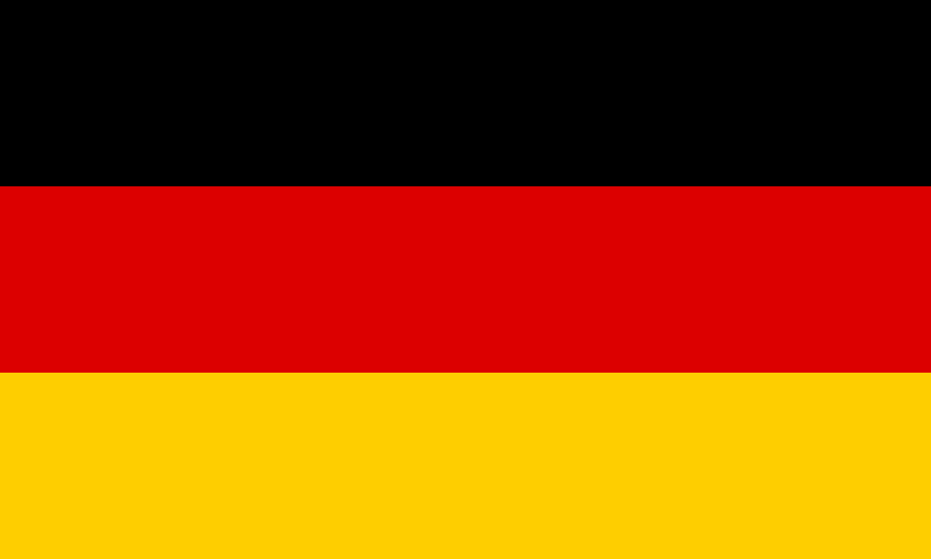

**Country:** Germany

**Committee:** Social, Cultural and Humanitarian Committee

**Agenda Item:** Ensuring Equality of Opportunity on Children’s Access to Education

Germany is a country in Central Europe. It is bordered to the North by the North Sea, Denmark and the Baltic Sea, to the east by the Poland, to the South by Austria and Switzerland, and to the west by France, Luxembourg, Belgium and the Netherlands. Germany has a population of 83 million people. Foreign trade, industrial production, automotive, food, agriculture, animal husbandry and tourism are among the country’s main sources of income.

Education is one of the most fundamental rights that every child has from birth. Education integrates the child into society as a responsible person. Education also teaches children at an early age that certain behaviors are harmful and should be avoided. This helps the child to understand what is harmful and what is wrong to do. With education, the child becomes an individual who can distinguish between right and wrong and make the right decisions.

As important as education is, most children in the World are being deprived of it. Rural and underdeveloped areas have few or no schools, preventing children in these areas from exercising their right to education.

For some children, families can not afford the necessary materials for the schools where they live and do not want to send their children to school. Some families with the means prefer to put their children to work at an early age instead of sending them to school. Some schools are so dirty and lack basic supplies that parents do not want to send their children there. Inadeaquate or incorrect education in schools is another reason why families do not send their children to school.

Germany has ratified the United Nations Convention on the Rights of the Child. With this convention, the country undertakes the obligation to ensure the well-being of children and protect children’s rights.

Germany will build new schools in rural and underdeveloped areas and provide basic materials for children who can not afford them. Germany will also make sure that schools are clean and have basic materials.

**Bibliography**

<https://www.deutschland.de>

<https://www.google.com.tr>

<https://tr.wikipedia.org>