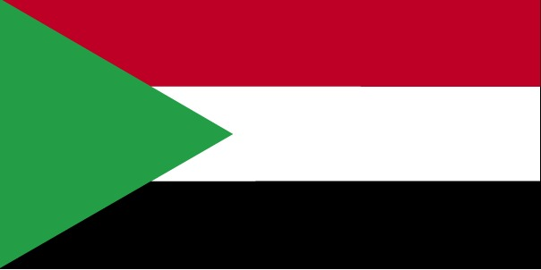

Committee: UN Environment Programme

Agenda Item :

1- Assessing the Current State of the Climate Crisis

2- Environmental problems regarding cities

Country: Sudan

Delegate: Batur Cingöz, Özel Bağlıca Tema Koleji Anadolu Lisesi

Located in the northeast of the African continent, Sudan has a surface area of ​​1,886,068 km square. Country; It borders South Sudan in the south, the Central African Republic in the southwest, Chad in the west, Libya in the northwest, Egypt in the north, Ethiopia in the southeast, and Eritrea in the east. It also has 853 km of coastline, with the Red Sea to the east. According to current data, the population of Sudan is 45.6 million. According to Sudan's 2017 GDP data, 58.8 percent of its economy is covered by services, 39.6 percent by agriculture, and 2.6 percent by industry. 70 percent of Sudan is Sudanese, the remaining 30 percent is made up of Fur, Beja, Nuba, Ingessana, Uduk, Fallata, Masalit, Dajo, Gimir, Tunjur, and Berti; It consists of more than 500 ethnic groups. Although Arabic and English are used as official languages, Nubian is also used.

As Sudan, we are aware of the challenges posed by the climate crisis, and to combat these challenges, the Sudan EbA project is being implemented with the general aim of increasing the resilience of livelihoods and agricultural systems in White Nile State through EbA approaches. The project includes pasture , planting trees , rainwater harvesting, and drought-resistant agriculture. At least 6,800 households will be provided with access to food and water resources that are resilient to climate change. The project will build 10 water tanks and wells, and at least 3,200 men and women will be provided with access to solar-powered hand pumps for these wells. Approximately 200 rainwater harvesting pits will be installed on 2,000 community farms. Communities are also trained in climate-resilient livelihood practices such as coop animals farming and home garden farming.

All the operations of the committee, the issue of pollution caused by war remnants was among its priorities, jointly with the relevant authorities. He emphasized the importance of reducing impacts from pollution and protecting the safety and health of citizens

As Sudan, we care about the environment and believe that we should be sensitive about this issue. We believe that every city is the symbol of Sudan. And we are working on this issue. Sudanese Minister of Health Dr. (Haitham Muhammad Ibrahim), in his meeting with the committee responsible for the elimination of environmental pollution, said that while planning all the operations of the committee, the issue of pollution caused by war remnants was among its priorities, jointly with the relevant authorities. He emphasized the importance of reducing impacts from pollution and protecting the safety and health of citizens

As Sudan, we take care to keep the city clean and we see the city as a symbol of our country.