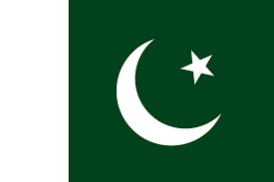

Commitee: H-UNSC

Topic: The situation in Bosnia and Herzegovina

Country: Pakistan

Pakistan is a country located in South Asia. It has a coastline along the Arabia Sea and the Gulf of Oman and is bordered by Afghanistan, China, India, and Iran. The geography of Pakistan is diverse with the Thar Desert in the east and the Hindu Kush and Pamir mountain ranges in the north.

As known , there was a big conflick between Muslims and non-muslims in Bosnia Herzegovina from 1992 to October 11 1995. During this time, despire efforts by United Nations Security Council to maintain peace and procect to constitunal system, difficulties arose in 1995 that led to massacres.

As Pakistan We sided with the Bosnian Muslims during the Bosnian War, providing them with as much military and humanitarian aid as possible. This shows that we were one of the countries taking sides at the time. Now, we will do everything in our power as Pakistan to rewrite history and ensure diplomatic compromise to prevent the war.

With Rescpect

The delagate of Pakistan, Beyza Yeygel