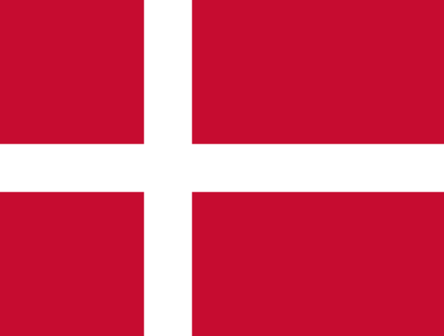

# KINGDOM OF DENMARK

country : kıngdom of denmark

commıttee : unesco

agenga ıtem : preservıng cultural herıtage

Honourable Chair and esteemed delegates,

Kingdom of Denmark thinks preserving cultural heritage is not merely a choice, but an obligation. Our cultural heritage serves a testament to our identity, history, an values. It connects us to our roots and provides a foundation for future innovations. However, numerous threats loom over cultural heritage, making its preservation crucial.

When we talk about cultural heritage, we are referring to the tangible and intangible aspects of our shared history. It encompasses the physical structures, artifacts, and artworks that have been passed down through generations, as well as the customs, traditions, and knowledge that define our communities. Cultural heritage is a living entity, constantly evolving and shaping our present and future.

Denmark has implemented various initiatives to preserve its cultural heritage. One specific example is the Danish Cultural Heritage Agency's efforts to protect and maintain historic buildings and sites. They provide funding for restoration projects, conduct research on cultural heritage conservation, and offer guidance to property owners on preservation techniques. Additionally, Denmark has designated certain areas as UNESCO World Heritage Sites, such as the Jelling Mounds, Runic Stones and Church, to ensure their protection and promotion for future generations.