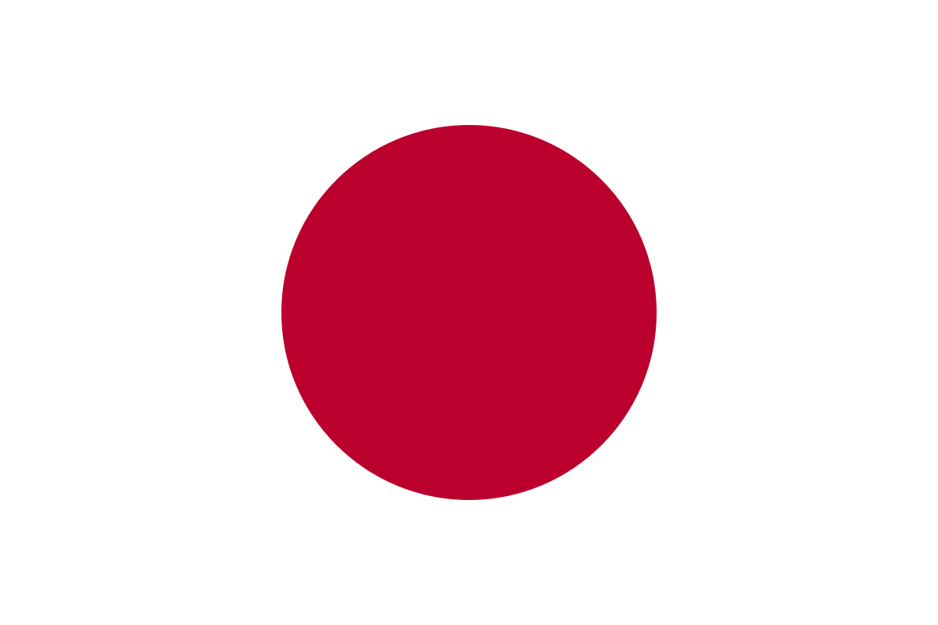

Committee: İnternational Labour Organization

Country: Japan – Employers’ Representative

Agenda: Achieving the Decent Work Agenda Through Reinforcement of Collective Agreements

Delegate: Bilge Deren Çelik

Japan has the world's fourth largest economy after the USA, the People's Republic of China and Germany. As of 2024, the unemployment rate in Japan is 2.5 percent. Japan was one of the founding members of İnternational Labour Organization when it was established at 1912 following the WW1. Japan became a member of organization on 28 April 1912. Since then, Japan’s unemployment rates and labour rights gone though significant changes. Back then, labour right were inhumane with poor working conditions, low wages, long working hours and gender discrimination, etc. With Japan’s membership in ILO, Japan began to stick with the international labour standarts. But industrial policies were stil focused more on economic growth so labour rights couldn’t supported enough.

At 1947 Japan recognized The Labour Standarts Law, which contains the rights to collective bargaining and srike etc. İn the 60’ – 70’s time period Japan gone through a fast economic growth. This helped with some improwements in labour rights, for example heathcare, education and better working conditions. Also this situation brought some serious problems like ‘karoshi’. Karoshi knowns as ‘owerwork deaths’, the most common causes of karoshi deaths are sudden heart attacks due to stres and tiredness. Also some workers commited suicide duo to mental stres from the harsh workplace conditions. At the moment, karoshi syndrome became a serious global issue. In recent decades, Japan puts a lot of effort to protect labour rights and prevent this type of problems. Since 1990 Japan has made important innovations about labour rights. Recognition of the negative effects of excessive working hours and stress across the country, has led to policies to prevent karoshi. Japan has made reforms to limit working hours and increase overtime pay to reduce health problems caused by overwork. It was recognized that employees cannot work for 12 or more hours a day, 6–7 days a week, year after year, without suffering physically as well as mentally. In June 2014, the Japanese Government passed the “Act on Promotion of Preventive Measures against Karoshi and Other Overwork-Related Health Disorders”.

 To increase female labour force participation Japan introduced numerous laws. One of the most important one is Equal Employment Opportunity Law (1986), this law also provided amendments to the Japanese Labor Standarts Act of 1947 and the Working Women's Welfare Law. Japan also implemented legal chances to protect the rights of trade unions and strenghten their place. For example Labour Union Law (1949) aimed to guarantee rights of workers from unions and Japanese Constitution (1947) guarantees the right of workers to organize and bargain collectively. It states that workers have the right to form and join unions and to bargain collectively with employers.

Despite these we cant claim that we totally achieved the decent work agenda. Japanese employers face the challenge of providing fair and safe working environments for workers while also protecting their business interests. Establishing this balance is crucial not only for worker productivity and rights, but also for the sustainability and success of businesses. To help Japan’s employer’s to protect their profits while providing good working conditions automation and digitalization should be used extensively at work. The use of automation, digitalization and the AI helps reduce simple labor and enable employees to concentrate on more creative and important work. Thus, there is a decrease in the employees' busy work schedule and working hours. Having physical labor and simple tasks be the duty of robots rather than humans will reduce the workload and reduce the stress on employees. Since work that used to be done for long hours with human power can be done much faster and more cost-effectively with digitalization, both the working hours of employees decrease and the profits of employers increase. Government-supported mental health programs can be created to improve worker performance and protect the mental health of workers. While we try to prevent workers from working in harsh conditions and the unfortunate consequences of this situation, we try to increase the workforce and protect our interests.

<https://en.wikipedia.org/wiki/Member_states_of_the_International_Labour_Organization>

<https://en.wikipedia.org/wiki/Karoshi>

<https://www.nippon.com/en/currents/d00310/>

<https://pmc.ncbi.nlm.nih.gov/articles/PMC10746923/#:~:text=Karoshi%20syndrome%2C%20also%20known%20as,due%20to%20Karoshi%20syndrome%20globally>.

<https://www.warnathgroup.com/wp-content/uploads/2015/03/Japan-Labor-Standards-Law.pdf>

<https://en.wikipedia.org/wiki/Equal_Employment_Opportunity_Law_(Japan)#:~:text=The%20Act%20on%20Ensuring%20Equal,designed%20to%20implement%20an%20earlier>

<https://natlex.ilo.org/dyn/natlex2/r/natlex/fe/details?p3_isn=27190>

<https://www.cfr.org/japan-constitution/japans-postwar-constitution>

<https://www.jniosh.johas.go.jp/en/indu_hel/doc/IH_55_3_293.pdf>

<https://www.eurofound.europa.eu/system/files/2015-02/ef1409en4.pdf>