
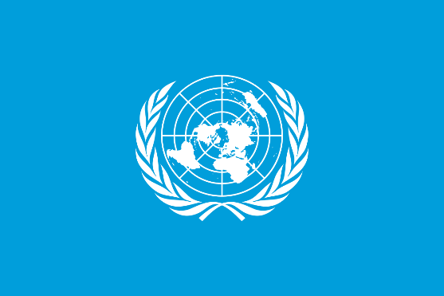

Pakistan is a country in South Asia. Pakistan is the fifth most populous country in the world with a population exceeding 241.49 million. It has the second largest Muslim community. 25% of Pakistan's population consists of children and 28,000,000 of them do not go to school.
UNICEF is a United Nations agency responsible for providing humanitarian and developmental assistance to children around the world, and UNICEF relies entirely on voluntary contributions from governments and private donors. UNICEF works in over 190 countries and territories to save children's lives, to defend their rights, and to help them fulfil their potential, from early childhood through adolescence. And they never give up. As UNICEF, we deliver basic services such as education, health, nutrition, protection, water, sanitation and hygiene to those who need them most and eliminate inequalities in each of these areas . All of its programs, partnerships and global advocacy work pursue one goal: to ensure that every child grows up healthy, educated, protected and respected. Vaccination of children against vaccine-preventable diseases. Fighting malnutrition. Supporting mental health.
12,600,000 of the children who do not go to school are girls. It is possible to say that children who go to school receive an inadequate education. 65% of students cannot reach the level they should reach when they complete primary school. Girls and poor students are much less likely to go to school than other students. Terrorist incidents also make parents uneasy, especially about sending girls to school. During attacks, school buildings can be destroyed and teachers can be the target of attacks. As UNICEF, we aim to solve infrastructure deficiencies in education, insufficient personnel, and corruption in educational institutions and personnel recruitment in Pakistan.
There are many diseases that cause child deaths. One of the two countries where polio is endemic is Pakistan. This disease, which spreads rapidly in environments where environmental and food cleanliness cannot be ensured, causes serious consequences such as death, lifelong paralysis and the inability to breathe without respiratory support; There are also some problems that children face due to malnutrition. In Pakistan, 29% of children are underweight for their age, while 40.2% are short for their age. 56.6% of girls face the problem of anemia. Pneumonia and diarrhea are the leading causes of child death. With the World Health Organization, we will reduce child deaths by accelerating vaccination processes in children at an early age. We will raise awareness on social media platforms to provide access to healthy foods for those suffering from malnutrition, and provide funding and donation support for healthy foods around the world.

