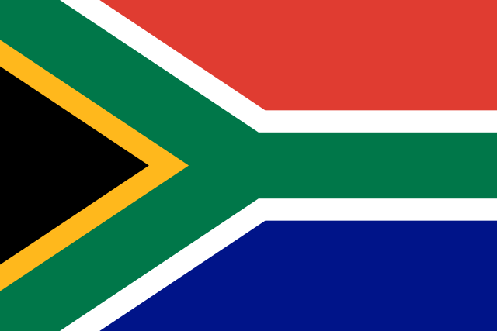 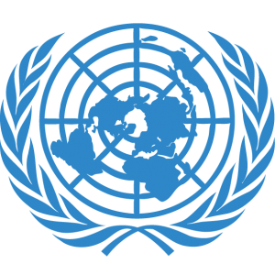

Name: Celal Emir Gündüz

Country: South Africa

Committee: DISEC (Disarmament and International Security Committee)

Topic: Proliferation of Nuclear Weapons in the Russo-Ukrainian War

Honorable Chairs,

The Republic of South Africa welcomes the opportunity to join this MUN conference to discuss proliferation of nuclear weapons in the context of the Russo-Ukrainian conflict.We want to keep the international peace and security and supporting non-proliferation and making our decisions according to these principles.

Our public firmly believes that use or threat of use of nuclear weapons is not acceptable under any circumstances and has a big risk for the world and life. Following this opinion we haven't had any nuclear arsenal since the 1990s thanks to these principles .We understand the results of nuclear proliferation and invite every country to gain these principles for world’s peace.

We are one of the first countries that signed non proliferation of nuclear weapons (NPT) in 1991 and with this agreement we annihilate all our bombs.We are feeling honored to take care of this problem early and ready to spread and dictate these ideas to other peoples.

Because of these policies we are not allowing any nuclear war.We don’t have a side on this war. The factor that makes it dangerous is the powerful and modern atomic bomb threat so this problem affects every country.The risk is becoming bigger and bigger and to solve this problem every country should get a non proliferation friendly perspective and make it a part of their public.The world needs diplomatic and peaceful actions to end this war and risks.

To solve this problem South Africa is suggesting supporting every council and signature that is against proliferation and wants its importance to be understood by every country.We are not allowing any action that causes nuclear weapon producing and suggesting to control these actions for example nuclear and chemical equipment and product tradeship and delivery.

Thank you.

Delegate of South Africa