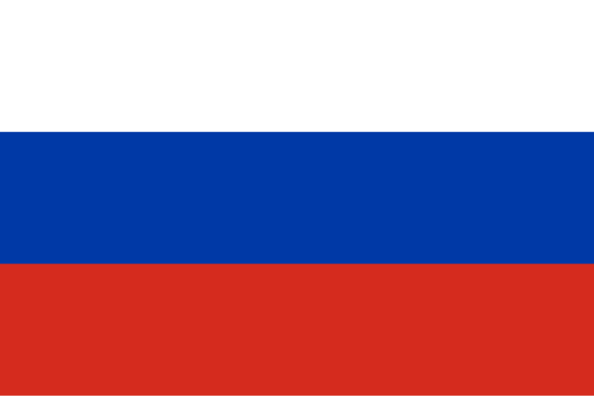

Country: Russian Federation

Committee: SOCHUM

Agenda Item: Ensuring Inequality of Opportunity on Children's Access to Education

The Russian Federation has a population of approximately 144 million people and is located in both Eastern Europe and Northern Asia. It is a Eurasian country with neighbors including Norway, Finland, Estonia, Latvia, Lithuania, Poland, Belarus, Ukraine, Georgia, Azerbaijan, Kazakhstan, China, Mongolia, and North Korea. Around 30 million children live in Russia, and the country has a literacy rate of 99.7%, with nearly equal literacy levels for men and women. Higher education is also prominent, with 53% of adults aged 25 to 64 holding college degrees. Russia has a life expectancy of 73.12 years and a GDP per capita of $26,100, contributing to an economy valued at $1.268 trillion. Natural gas is one of the country's main resources.

Russia recognizes that educational inequality is a serious issue that must be addressed promptly because the future depends on today’s children. Russia actively supports global education initiatives led by UNESCO. These efforts aim to ensure equal access to education for all, particularly for girls, children with disabilities, and those affected by conflict. The Russian Federation also provides financial aid and builds schools in developing countries like Bangladesh, India, Pakistan, Nigeria, and Afghanistan, where education systems often lack resources to provide equal opportunities.

To solve educational inequality, Russia believes in the importance of training teachers and making children aware of this issue. Schools should address differences in financial conditions by lowering registration fees to make education more accessible. Teachers need seminars to better understand the problem and how to address it in classrooms. Russia also recommends seeking assistance from the United Nations to support these efforts and encourages all countries to collaborate on this issue.

Educational inequality is a global problem, and the Russian Federation calls on other nations to unite in addressing this challenge to ensure every child has access to education.

References:

<https://datacommons.org/>

<https://pressbooks.pub/>

<https://en.wikipedia.org/>

<https://delegatepal.com/>

<https://data.unicef.org/>

<https://www.macrotrends.net/global-metrics/countries/rus/russia/life-expectancy>