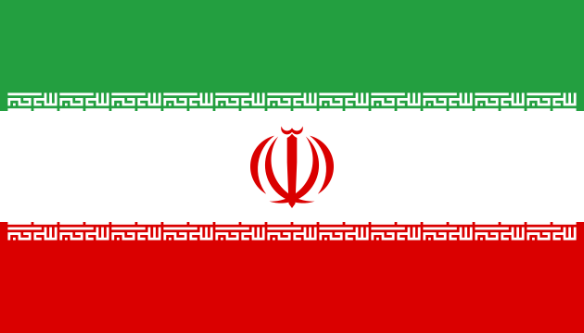

**[Country Name :Iran]**

**[Committee :United Nations Human Rights Council]**

**[Agenda :Preserving the human rights of Uyghur Turks]**

Iran is one of the few countries in the Middle East with a rich culture. Its geographical location, being an important part of the Silk Road throughout history and being home to various ethnic groups has made Iran an important global actor.

We are here to protect the human rights of Uighur Turks, an issue that Iran is extremely sensitive to. Iran has a long history of ethnic and religious diversity and we believe that protecting and respecting this diversity is one of the fundamental principles of Iran.

As an important country in the Islamic world, Iran also feels responsible for protecting the rights of Uyghur Turks, who are part of the Islamic community. Iran takes a humanitarian approach to the problems of the Uyghur Turks and tries to develop policies in this direction. In addition, Iran recognizes the regional implications of the situation of the Uyghur Turks in Central Asia, particularly on China's western borders. Iran and its people stand ready to defend the rights of the Uyghur Turks and play an active role in this regard in order to maintain regional stability.

Iran is already balancing its diplomatic relations and trade interests with China while being careful to protect the rights of the Uyghur Turks. One of Iran's goals is to adopt a balanced approach between maintaining relations with China and defending the human rights of Uyghur Turks.

The honorable President of Iran said in a speech ,"The issue of human rights of Uyghur Turks is of great importance for us in Iran. Justice and human rights are fundamental values of Islam and it is our responsibility to protect them."We cannot remain silent in the face of the hardships faced by Uyghur Turks. We call on the international community to take action to defend the rights of Uyghur Turks. Iran is ready to take the lead in this regard and we will never stop defending them. We will never stop defending them," he said, emphasizing the universality of human rights.

Iran is a signatory to the United Nations Universal Declaration of Human Rights. This declaration emphasizes the universal recognition and protection of human rights.

The International Convention against Torture and Other Cruel, Inhuman or Degrading Treatment or Punishment is a convention signed and ratified by the Iranian government. It prohibits torture and ill-treatment and aims to protect human rights.

Iran believes that direct dialog with the Chinese government is one of the best ways to discuss the rights of Uyghur Turks and cooperate in finding solutions.

Iran is ready to play a constructive role in cooperating with the international community to seek common solutions to protect the human rights of Uyghur Turks. It is willing to increase its efforts in this regard through the UN and other international organizations.

References

* <https://tr.euronews.com/2020/07/07/aralar-nda-musluman-ulkelerin-de-bulundugu-46-hukumetten-cin-in-dogu-turkistan-politikas-n>
* <https://tr.wikipedia.org/wiki/Uygur_Soyk%C4%B1r%C4%B1m%C4%B1>
* <https://ihh.org.tr/public/publish/0/30/dogu-turkistanda-asimilasyon-ve-ayrimcilik.pdf>
* <https://turkistanpress.com/page/ahmedinejad-39-dan-cin-39-e-ve-iran-rejimine-uygur-tepkisi/2991>