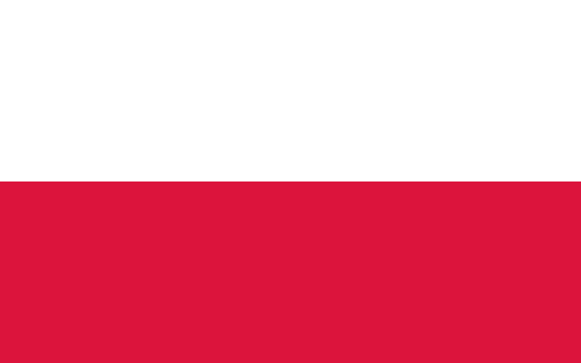

**Committee**: SOCHUM (Social, Humanitarian and Cultural Committee)

**Country**: Poland

**Agenda** **Item**: Enhancing Access to Educational Opportunities for Children Globally

Poland, officially the Republic of Poland, is a country in [Central Europe](https://en.wikipedia.org/wiki/Central_Europe). Poland is composed of [sixteen voivodeships](https://en.wikipedia.org/wiki/Voivodeships_of_Poland) and is the fifth most populous [member state of the European Union](https://en.wikipedia.org/wiki/Member_state_of_the_European_Union) (EU), with over 38 million people, and the [fifth largest EU country](https://en.wikipedia.org/wiki/List_of_European_countries_by_area) by land area, covering a combined area of 312,696 km2 (120,733 sq mi). The capital and [largest city](https://en.wikipedia.org/wiki/List_of_cities_and_towns_in_Poland) is [Warsaw](https://en.wikipedia.org/wiki/Warsaw).

Currently, there are over 700 million people in the world who are not able to write and read. Most of them are women. Almost three times as many do not have access to a stable education system. Without these basics, people are cut off from information, knowledge, and truth. Without that they become more vulnerable to manipulation, social inequalities, exploitation, objectification, or even slavery. The Learning Passport, an e-learning platform from Microsoft and UNICEF, was launched today to support the inclusive education of refugees in the Polish school system. Poland becomes the first country globally to launch a version of the tool specifically for teachers, with courses on managing stress, cross-cultural communication and working with children from Ukraine who are suffering from the trauma of war. Launched in 2018 and now present in 32 countries, Learning Passport enables children and young people, including those in displaced or crisis-affected communities, to access quality inclusive education and build the skills they need for a brighter future.

As Poland, we believe that each of the mentioned problems can be solved in two ways: on an ad hoc basis – through recovery policies and programs, and in the long term – through raising self-awareness and a sense of global community by providing the necessary knowledge and tools to regions of the world that need support. This bottom-up proposal also helps in tackling such problems as migration, climate change, and economic crisis after the pandemic. We can provide financial and moral support,increase investment in science, technology, engineering, and mathematics (STEM) to build a qualified workforce in these areas,provide scholarships and financial assistance to disadvantaged families to prevent dropouts.

Source:

<https://study.gov.pl/news/how-increase-access-education-world-there-suggestion-polish-students>

<https://www.unicef.org/eca/press-releases/global-e-learning-platform-launched-poland-support-inclusion-refugees-and-mental>