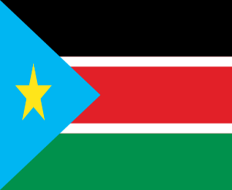Commite: UNFPA

Country: South Sudan

Agenda Item: Global health strategies to reduce chıld mortalitiy

South Sudan, officially the Republic of South Sudan, borders Ethiopia to the east, Sudan to the north, the Central African Republic to the west, the Democratic Republic of the Congo to the southwest, Uganda to the south, and Kenya to the southeast.

South Sudan has a population of approximately 12 million, mostly Nile people. About half of the population is under the age of 18, making South Sudan one of the youngest countries demographically. Most of the population practices Christianity and traditional religions. The independence of South Sudan was officially declared on 9 July 2011The Ministry of Health of South Sudan is a national ministry in the current Revitalized Transitional Government of National Unity (RTGoNU) in the Republic of South Sudan. The infant mortality rate shows how many of every 1,000 live births die by the age of 1. This value provides information about the health level of countries. The world average infant mortality rate is 49.4 according to the United Nations and 42.09 according to the World Factbook. The under-5 child mortality rate is 73.7 according to the UN. The infant mortality rate in South Sudan in 2024 is 57,665 deaths per 1,000 live births, a 1.56% decrease compared to 2023.

We, as South Sudan, have thought of ideas such as improving our hospitals and water resources for the child deaths that are increasing every year. At the same time, new vaccines need to be developed in every city to protect babies from certain diseases immediately after they are born.

<https://en.wikipedia.org/wiki/South_Sudan>