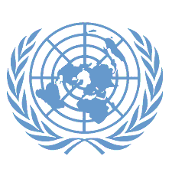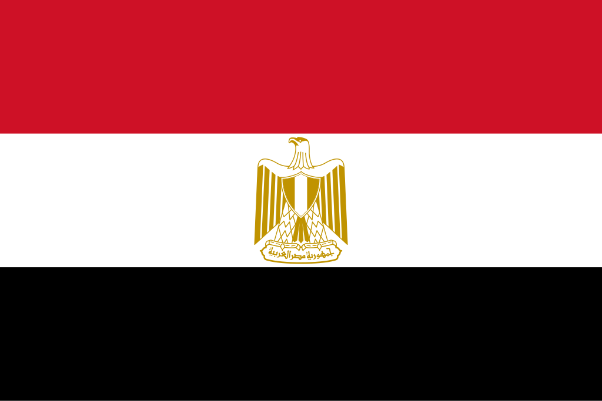**Conference: LIVJMUN24**

**Committee: UNESCO**

**Topic: Expanding global educational opportunıtıes and reducing inequalities in access to education**

**Country: EGYPT**

**Delegate: EZGİ SU PEDÜK**

Egypt is pleased to address the important issue of expanding educational opportunities and reducing inequalities in education. Egypt believes that access to quality education is a basic human right and essential for the development of every society. Education is key to improving lives, reducing poverty, and promoting peace. It is crucial that every child, no matter their background or where they live, has the chance to receive a good education.

Egypt has made progress in improving education, especially in rural areas. The government has built more schools and trained more teachers. However, challenges remain, such as overcrowded classrooms and differences in the quality of education between urban and rural areas. Egypt is also concerned about the global issue of education inequality, with millions of children, especially in low-income countries and conflict zones, unable to access education. Egypt has worked to offer free primary and secondary education and supports vocational training programs to help young people find jobs.

Egypt calls for more investment in education, especially in developing countries. More funding is needed to build schools, provide learning materials, and train teachers. Egypt also believes that we must find ways to make education available to children in rural and conflict-affected areas. This could include mobile classrooms, online education, and community-based learning programs to reach these children. Egypt recognizes the potential of technology to improve education. Digital tools and online learning can help overcome challenges like distance and lack of resources. However, Egypt stresses the importance of ensuring that technology is accessible to everyone, especially marginalized communities.