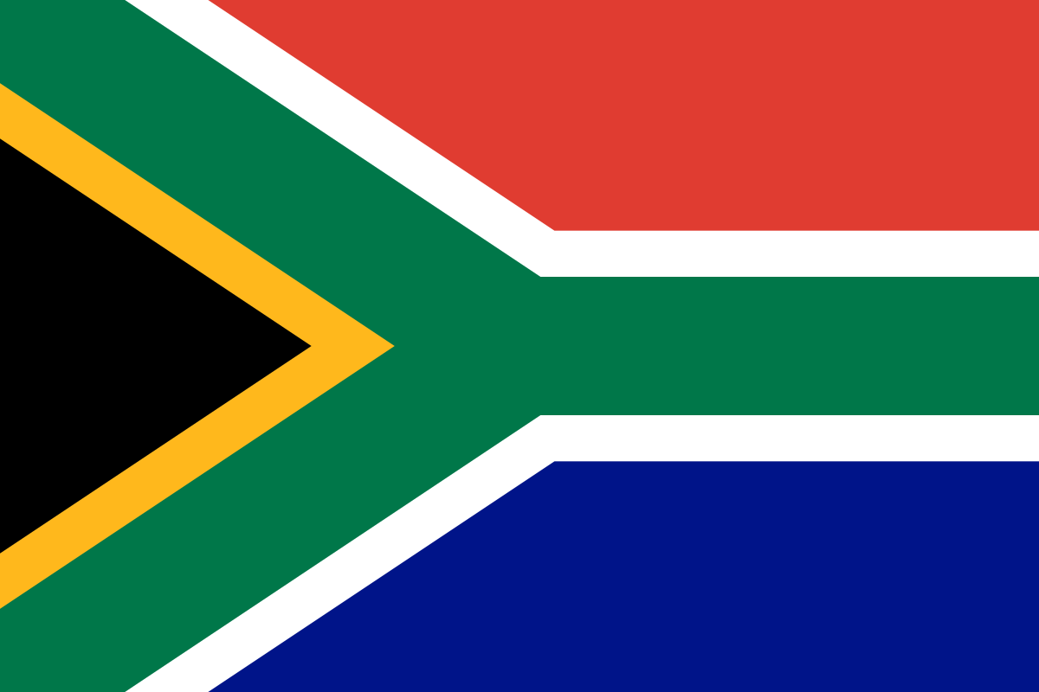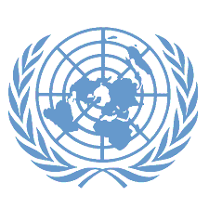Committee: DISEC

Topic: THE RUSSIA – UKRAINE WAR AND THE USE OF WEAPONS IN INTERNATIONAL LAW

Country: SOUTH AFRICA

South Africa takes a neutral stance on the Russia-Ukraine war, highlighting its negative impacts on global food security and energy prices. Facing issues such as prolonged conflicts, poverty, and displacement in Africa, the country advocates for dialogue and diplomatic solutions to achieve peace. At the same time, it struggles with serious internal challenges, including high unemployment, inequality, and poverty.

The Russia-Ukraine war, which began in February 2022, is rooted in the collapse of the Soviet Union and Ukraine's declaration of independence. Ukraine's efforts to strengthen its relations with the West, particularly NATO and the EU, are seen as a threat by Russia. Russia's annexation of Crimea in 2014 and its support for separatist movements in Eastern Ukraine further escalated tensions. The war has deepened global energy and food crises, displaced millions, and caused thousands of deaths. The international community is urgently calling for peace, but deep divisions between the parties make achieving lasting peace difficult.

To resolve the Russia-Ukraine war, an immediate ceasefire should be declared, and peace talks should begin between the parties. While Ukraine's territorial integrity must be preserved, Russia's security concerns should also be taken into account. The international community should monitor the ceasefire and ensure that humanitarian aid reaches the affected areas quickly. Given the economic crisis caused by the war, particularly its impact on food security and energy supply, global cooperation is essential to find solutions. Additionally, accountability for war crimes must be ensured, and perpetrators should be prosecuted. International efforts must unite to achieve lasting peace.