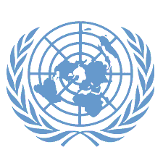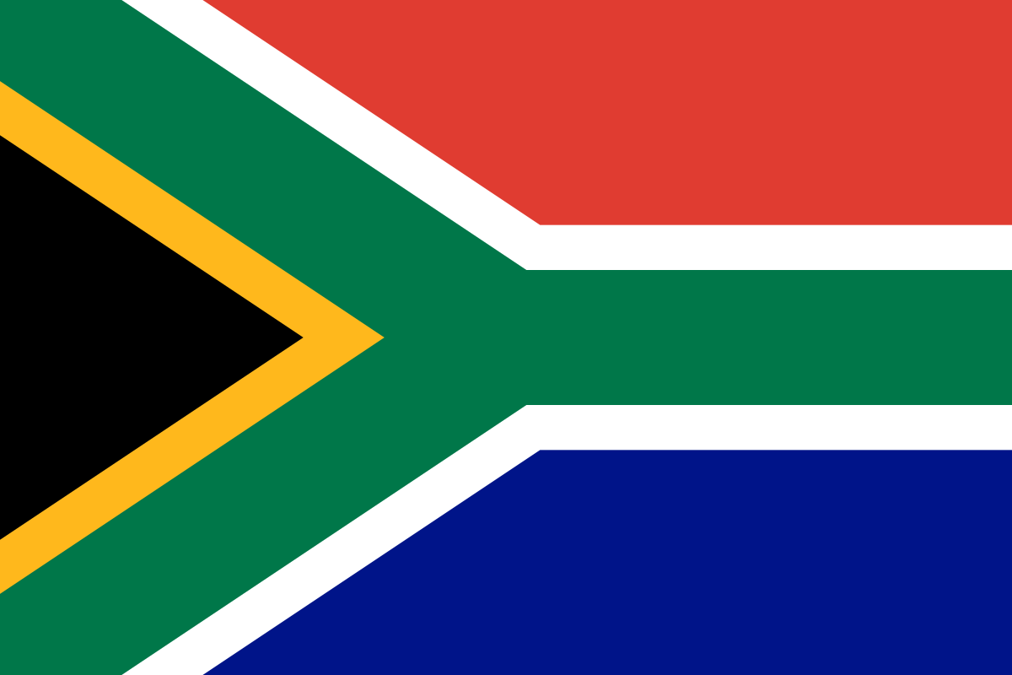Committee: UNESCO

Topic: EXPANDING GLOBAL EDUCATIONAL OPPORTUNITIES AND REDUCING INEQUALITIES IN ACCESS TO EDUCATION

Country: SOUTH AFRICA

South Africa, officially the Republic of South Africa (RSA), is the southernmost country in Africa. Its nine provinces are bounded to the south by 2,798 kilometres of coastline that stretches along the South Atlantic and Indian Ocean; to the north by the neighbouring countries of Namibia, Botswana, and Zimbabwe; to the east and northeast by Mozambique and Eswatini; and it encloses Lesotho.Covering an area of 1,221,037 square kilometres the country has over 62 million people. Pretoria is the administrative capital, while Cape Town, as the seat of Parliament, is the legislative capital. Bloemfontein has traditionally been regarded as the judicial capital. The largest and most populous city is Johannesburg, followed by Cape Town and the busiest port city in sub-Saharan Africa, Durban.

The rate of literate people aged 15 and over across the country is 94.3%, according to 2015 estimates. While this rate is 95.5% for men, it is 93.1%. There is nine years of continuous schooling throughout the Republic of South Africa. The majority of schools in the country are public schools, but education is also provided in private schools. In the country, primary school education is provided for seven years for a child who turns seven and is free of charge. This is a period that starts after education and lasts two years, subject to high school fees. Since 1996, the candidate to go to school ends after two years of high school education.The Republic of South Africa has some of the most important universities on the African continent. The University of Cape Town is the best university on the African continent, ranking 107th among the best universities in the world in the 2010/2011 academic year. One of the biggest problems in education around the world is educational inequality. in education inequality; gender-based inequalities, inequalities arising from socioeconomic background, ethnic classify them as inequalities based on origin and inequalities arising from school-teacher It is possible. The basis of gender-based inequalities is the burden that society has placed on individuals for centuries.

There is an understanding based on the belief that all individuals should be aware that they have the right to education and that education plays a fundamental role in the development of individuals and social and economic development.UNESCO has been at the forefront of global literacy efforts since 1946, advancing the vision of a literate world for all. It sees acquiring and developing literacy skills throughout life as an essential part of the right to education. The “multiplier effect” of literacy empowers people, enables their full participation in society and contributes to improving livelihoods. South Africa is ready to achieve all goals set by UNESCO and contribute.