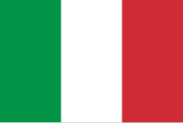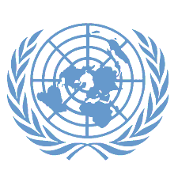Conference: LIVJMUN24

Committee: UNEP

Topic: GLOBAL SOLUTIONS FOR REDUCING MARINE PLASTIC POLLUTION

Country: ITALY

Italy is bordered by France, Switzerland, Austria, and Slovenia to the north, and is surrounded by the Mediterranean Sea to the south. The country boasts a diverse landscape, including the Alps in the north, rolling plains, and a vast coastline The Italian coastline stretches for more than 7,000 kilometers, making the country highly reliant on its marine environment for tourism, commerce, and biodiversity.

Italy aims to reduce pollution problems and become cleaner through co-operation. Italy supports efforts to protect seas, oceans and waters and we consider and explore what materials can be used to replace plastics. Italy contributes to efforts to reduce water pollution, use less plastic and replace plastics with other waste through co-operation agreements between all nations, taking into account national rules. The Italian government has recognized the importance of preserving the cleanliness of its seas and has implemented several national and regional policies to address marine pollution. These include stricter regulations on waste management, efforts to reduce plastic consumption, and initiatives to improve sewage treatment systems. Italy has also taken part in various international agreements aimed at protecting the Mediterranean and other surrounding seas, working with neighboring countries to establish measures for reducing pollution and promoting sustainable marine practices.

Willing to cooperate with all countries In conclusion, Italy believes that action must be taken to address water pollution. We need to do more to protect our water resources and ensure that we have clean water in the future. Italy is to find solutions for cleaner, healthier water.