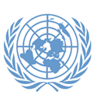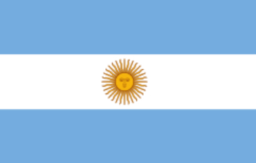

Committee: WHO

Topic: THE IMPACT OF CLIMATE CHANGE ON GLOBAL HEALTH AND MITIGATION STRATEGIES

Country: ARGENTINA

Argentina is a country in South America, bordered by Chile, Bolivia, Paraguay, Brazil, Uruguay, and the South Atlantic Ocean. With a population of over 45 million, it is the second-largest country in South America by land area. Argentina has a growing economy based on agriculture, industry, and services, and follows a federal republic system with a presidential government.

Argentina acknowledges the serious threat that climate change poses to global health and the need for effective solutions. The country is highly affected by climate change, with issues such as rising temperatures, extreme weather, and changing disease patterns. These factors contribute to health problems like respiratory illnesses and waterborne diseases due to floods and droughts.. The cabinet established national climate change action plans in the forestry, energy and transport sectors, which led to Argentina becoming the first country to submit its Nationally Determined Contribution (NDC) to the United Nations Framework Convention on Climate Change (UNFCCC) in 2016. If the mitigation measures in the sectoral action plans are fully implemented, they will help Argentina exceed its unconditional NDC target.Argentina's NDC aims to decarbonise the transportation sector. Strategies to achieve decarbonisation are detailed in the 2017 National Transport and Climate Change Plan, which aims to implement policies for urban mobility, cargo and heavy goods transport and intercity mobility to achieve this goal.

The energy sector, considered the sector with the highest mitigation potential in Argentina, is addressed in the 2017 National Energy and Climate Change Plan. The measures and legislation detailed in the Plan will address both the supply and demand sides of energy use, from increasing the use of renewable resources such as biofuels to improving the energy efficiency of households.