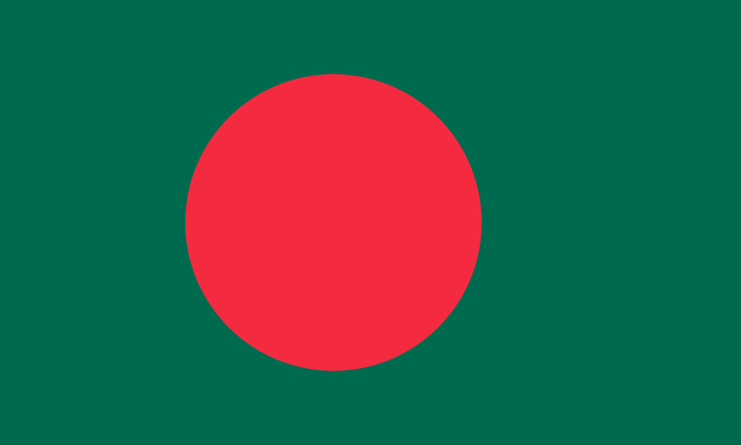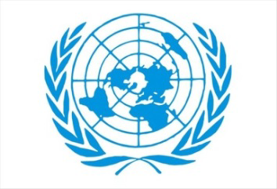Committee: Social, Humanitarian and Cultural Committee (SOCHUM)

Topic: Ensuring Equality of Opportunity on Children’s Access to Education Country: Bangladesh

Bangladesh is located in South Asia, also known as Sub-Saharan Africa. It is a country centered in Dhaka. It is the 8th most populous country in the world with 173 million people living there, and 91% of this distribution believes in Islam, which is considered the official religion. It is thought that more than 63 million children between the ages of 6-22 do not have access to the right to education, an estimated 13 to 17 million. Ensuring that all children have an equal chance to receive education is very important, and the sources of light of the future create a great chance for children. A child's development is very important for job opportunities and the ability to take part in society. Education helps children learn, grow and have more opportunities in the future. However, they do not have the same chance to go to school. Some children face difficulties in preventing them from getting a good education.

The difficulties in education are caused by poverty, gender discrimination, lack of infrastructure, and transportation. New data from UNESCO shows that the number of people going to school has increased by 6 million since 2021, reaching a total of 250 million.It is clear that countries need to quickly turn this increase around and ensure that they continue their education while the UN General Assembly is in the system to continue progress by 2030. The main reasons for the increase in children who are out of school: In Afghanistan, we are talking about a large number of girls and young women who are not allowed to go to school. In order to prevent this situation from happening in Bangladesh, UNESCO and UNICEF have carried out various studies to increase school enrollment rates and make education possible, but despite all this, it is still not enough for today. Although not directly related to education, SOCHUM has addressed the issues of education rights and equal opportunities in education as part of social, cultural and humanitarian affairs, contributing to the creation of this life globally.

Countries with GDP can provide developmental aid to provide alternative education in need. They can provide aid such as free technological school facilities support, more schools in rural areas, and special programs for children who need extra help. With a fair chance to learn in all areas, we can help create a world where everyone has the opportunity to succeed. This goal focuses on ensuring that no child is left behind, regardless of where they live, their income and their background. The UN also encourages schools in countries to help, train teachers and support programs that support children who face difficulties in getting an education There is no doubt that the aid services provided by world giant donor countries such as the USA, France, Germany and other powerful countries such as Bangladesh, which are developing in education, will have a positive impact on the world by bringing these countries to the top ranks in education.