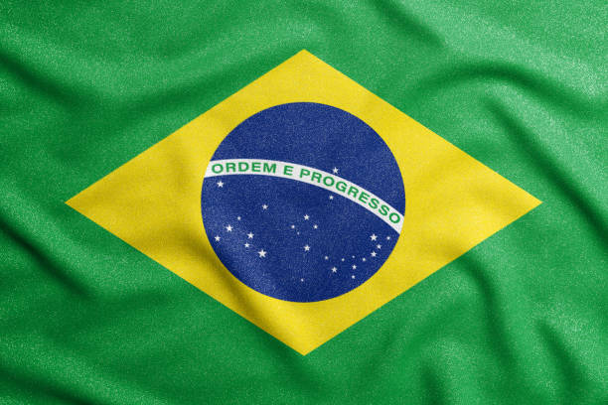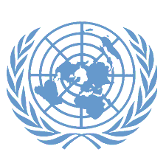

Committee: UNEP

Topic: GLOBAL SOLUTIONS FOR REDUCING MARINE PLASTIC POLLUTON

Country: BRAZIL

Brazil is the fifth largest country in the world in terms of area, after Russia, Canada, the USA and China. The territory of this country is spread over 4 different time periods. Brazil also has a 7,367 km long coastline bordering the Atlantic Ocean. The Brazilian economy, the largest economy in Latin America, is a thriving mixed economy. Brazil is one of the richest countries in the world in terms of forest and water resources. The Amazon forests are the largest tropical forests in the world, and the Amazon River is the second longest flowing water in the world after the Nile River.

Garbage, especially plastic waste, thrown into the Brazilian seas threatens the ocean ecosystem. These wastes pollute the habitats of marine creatures and reduce the survival of many species. For example, sea turtles and whales may face the risk of death by swallowing plastic horses and Although there are some environmental initiatives to combat littering in the seas in Brazil, the public and local governments do not seem to have sufficient power on this issue. This deficiency makes it difficult to combat marine pollution.

In conclusion, Brazil intents to stop water pollution and cooperate with the United Nations to prevent the future extinction of aquatic animals, to prevent health problems and to prevent many problems that UN can list.