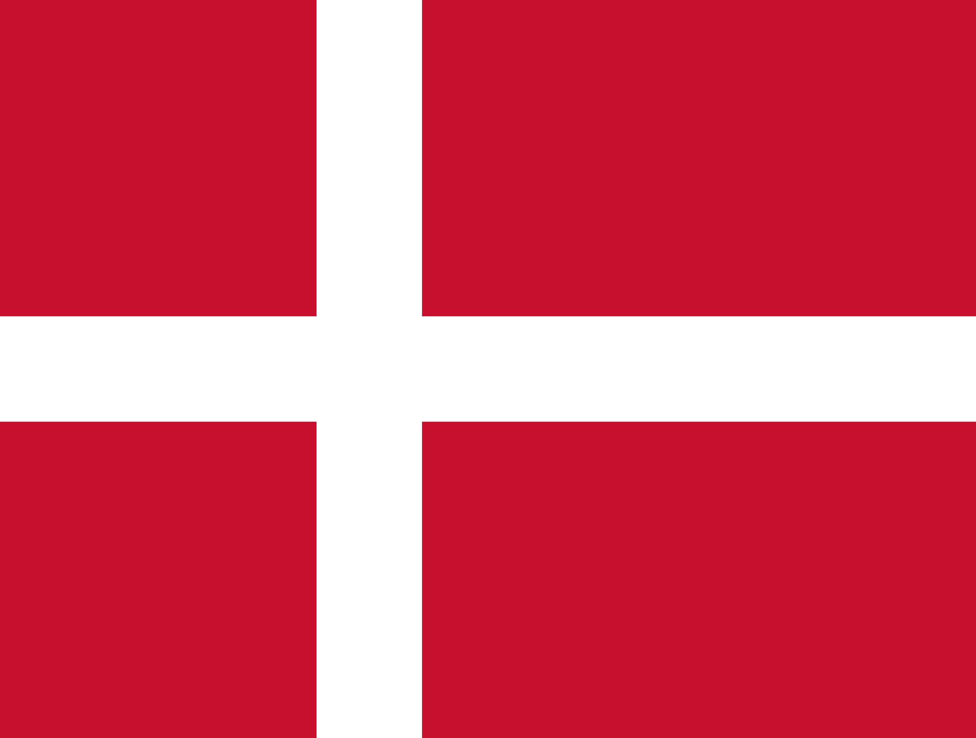
Committee: Social, Humanitarian, Cultural Commitee (SOCHUM)

Topic/ Agenda: Seeking Solutions for Human

Rights Violations Derived from Ethnic Divides.

Country: The Kingdom of Denmark

Delegate’s Name: Hatice Sayiç

Denmark has a long-standing history of protecting human rights and resolving conflicts. Denmark is a founding member of the United Nations (UN) and has backed the Universal Declaration of Human Rights. Denmark has also signed and agreed to various international human rights treaties, including the European Convention on Human Rights, the Geneva Conventions, and the Rome Statute of the International Criminal Court (ICC).
Denmark uses a comprehensive strategy that includes education, economic development, and international cooperation to promote lasting peace and prevent human rights abuses related to ethnic conflicts.

Current Policies:
- The Danish Institute for Human Rights provides technical assistance and training on human rights, including how to apply a human rights-based approach to implementing the Sustainable Development Goals. The Institute facilitates courses in HRBA emphasizing the need for incorporating human rights in all aspects of the development work.

- Denmark aims to address the root causes of conflict by providing economic development assistance to developing countries. This aid focuses on areas such as education, healthcare, infrastructure development and poverty alleviation.

- Denmark was one of the first European countries to grant foreign residents the right to vote in local elections. The country focuses on creating inclusive governance structures to enhance the political and social integration of ethnic minorities. These efforts involve developing policies to ensure representation and participation of ethnic minorities in political processes.

Denmark's Assistance in Addressing Ethnic Conflicts in Myanmar and Congo:
- Denmark initiated the Myanmar Country Program between 2016-2020 with the aim of supporting the transition to democracy in Myanmar. This program implemented projects in three main thematic areas: peace, law and human rights, access to basic education, and inclusive and sustainable economic growth. Denmark aimed to reduce human rights violations and promote sustainable development in Myanmar through this program. Denmark provided funding to address health issues in Myanmar through programs such as the "Three Diseases Fund." This fund is used to combat HIV/AIDS, tuberculosis, and malaria.

- Denmark provides significant humanitarian aid in response to crises in the Democratic Republic of Congo (DRC), aiming to address basic needs such as healthcare, food security, water, and sanitation.

References:
- https://www.humanrights.dk/our-work/human-rights-education
- https://humanityinaction.org/knowledge_detail/moving-beyond-the-danish-identity-the-role-of-ethnic-minorities-in-forging-a-more-inclusive-society/
- https://migrant-integration.ec.europa.eu/library-document/political-participation-organisation-and-representation-ethnic-minorities-denmark_en
- https://www.humanrights.dk/our-work/human-rights-based-approach
- https://www.hrw.org/world-report/2024/country-chapters/democratic-republic-congo

Sincerely, the Delegate of The Kingdom of Denmark
Hatice Sayiç

