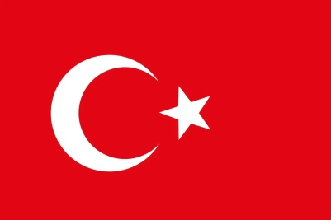Committee:The Disarmament and International Security Committee (DISEC)

Topic:Non-proliferation and disarmament of nuclear weapons

Country:Turkey

Turkiye is located in southeastern Europe and southwestern Asia with a population of 85 million people.Turkiye’s livelihood mostly depends on agriculture, tourism and various manufacturing industries.The country hosts many refugees from the neighbooring conflict regions.

Building on major scientific breakthroughs made during the 1930’s the United Kingdom began the world’s first nuclear weapons research project in 1941 during WW2. In August 1945 the atomic bombings of Hiroshima and Nagasaki were conducted. At the present day 9 countries in the world possess nuclear weapons. Turkiye is one of the six countries that host another nation’s nuclear weapons. The Treaty on the Prohibition of Nuclear weapons (TPNW) includes a comprehensive set of prohibitions on participating in any nuclear weapon activities.

These include undertakings not to develop, test, produce, acquire, possess, stockpile, use or threaten to use nuclear weapons. Turkiye is a member of the non-proliferation and disarmament initiative; a group of non-nuclear weapon states dedicated to disarmament non-proliferation and peaceful nuclear activities. Turkiye believes that to maintain international peace and security the UN needs to control and eventually help reduce the nuclear weapons around the world. It is a clear task of the most developed countries to lead the international community towards a more cooperative and less discriminatory environment, where the danger of nuclear annihilation will be drastically reduced and ultimately brought to zero.

References:

[www.bhfieldsschool.org](http://www.bhfieldsschool.org)

[www.disarmament.unoda.org/tpnw](http://www.disarmament.unoda.org/tpnw)  
[www.icanw.org](http://www.icanw.org)

[www.un.org](http://www.un.org)

[www.quora.com](http://www.quora.com)  
[www.en.m.wikipedia.org/wiki/History_of_nuclear_weapons](http://www.en.m.wikipedia.org/wiki/History_of_nuclear_weapons)

[www.nti.org](http://www.nti.org)  
https://www.un.org/en/chronicle/article/next-steps-universal-nuclear-disarmament