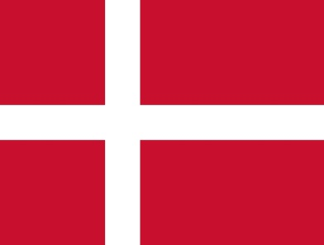

Committee: European Council (EC)

Topic: Refugee Problem in Europe

Country: Denmark

Denmark is a Nordic country in the south-central portion of Northern Europe. It is the southernmost of the Scandinavian countries, between Sweden, Norway and Germany. It has a population of around 5.8 million people and covers an area of approximately 42,924 square kilometers. The capital and largest city is Copenhagen, which is also one of the most populous cities in the Nordic region. Economically Denmark has strong emphasis on free trade, industries including pharmaceuticals, renewable energy, maritime shipping and information technology. Overall Denmark is a modern, highly cultural, and a progressive nation with rich history.

During the last decade, Europe has faced with its worst refugee crisis since the Second World War, with more than 1 million people applying for asylum in 2015 and 2016. The Syrian Civil War has been the main cause of the refugee problem towards Europe and has led to one of the largest refugee crises in history. However, in addition to Syrians, Afghans, Iraqis, and people from other countries torn apart by war or persecution undertake treacherous journeys to migrate to Europe. So we can understand that refugees leave their countries mostly because of wars. But why refugees coming to other countries is a problem? That’s because many refugees die on their way to the country that they are trying to go to. On the other hand refugees are a problem for countries too because a person in a new country doesn’t behave like a person who lives in that country. And that disturbs these countries in many ways such as politically, economically, socially, culturally and in means of security. In Denmark there are nearly 67,772 refugees and for Denmark’s population that’s a very high number. One of the reasons that Denmark doesn’t want refugees in their country is that they think the places that the refugees come from are safe to live in.

Denmark tried a few ways to solve refugee problems like building asylum centers for asylum seekers and refugees to live in, making them to move to 3rd world countries by paying money to the countries, and telling the refugees to go back to their countries. In my opinion these solutions that Denmark tried are bad for the refugees and there are many countries that have refugee problems and trying to solve them. If the countries that have refugee problems unite and work on projects like building safe zone border cities for the refugees to stay till the end of the war. As I said in the second paragraph the wars are one of the biggest problems for refugees to leave their countries so the countries that have refugee problems can unite to do something to stop the war in the refugees countries.

References:

1. https://en.wikipedia.org/wiki/Denmark
2. UN General Assembly, UNHCR Statute, 1950, www.refworld.org/docid/3ae6b3628.html
3. https://www.amnesty.org/en/petition/denmark-syria-refugees-return/
4. https://www.macrotrends.net/global-metrics/countries/DNK/denmark/refugee-statistics
5. United Nations High Commissioner for Refugees. UNHCR recommendations to Denmark on strengthening refugee population in Denmark, Europe, and globally. 2021.
6. https://en.wikipedia.org/wiki/List_of_sovereign_states_by_refugee_population