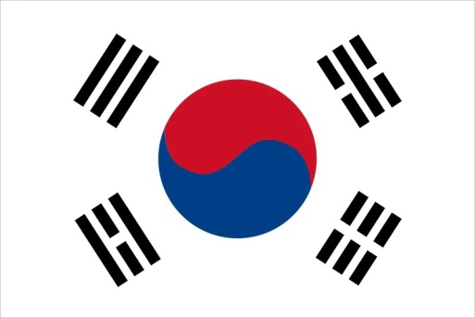Committee: United Nations Development Programme (UNDP)

Topic: Climate crisis adaptation and resilience.

Country: South Korea

The Republic of Korea commonly known as south korea is considered a regional power and a developed country,known for its visionary behavior in all types of international matters and also notable for its rapid economic development. South Korea’s culture has been heavily influenced by that of neighboring China, it has nevertheless independently managed to develop a unique cultural identity on its own.

The climate crisis that arises climate change does not only affect us but it deeply affects our beloved earth in many ways.Such as record| breaking heat,floods,stroms and wildfires devastating communities around the world.South Korea believes that adressing climate change does not place a burden but provides oppurtunities to create future drivers of economic growth.South Korea’s has actively engaged to tackle climate change by announcing it’s target to reduce greenhouse gas emissions,ratifying the Paris Agreement,adopting the basic plan for climate change and the Road Map to achieve national Greenhouse Gas Reduction Goals.The Republic of Korea has played a bridging and a huge role in the climate change negotiation process by the Framework Act which was signed in 2011 to provide global warming and climate policies.These domestic effots show that South Korea is commited to improving SDGs(Sustainable Development Goals)

South Korea suggests that the UN should focus more on green infrastructure which is an way to approach water and water cycle.Green infrastructure is economical and it bring quality to life and that way it can provide benefits to people and animals.It’s also important to reduce greenhouse gases like methane,fluorinated gases,carbondioxide that causes global warming.South Korea is ready to work with other nations and countries to maket he World and our enviorment better.

References:

<https://www.mofa.go.kr/eng/wpge/m_5655/contents.do#:~:text=As%20an%20effort%20to%20join,which%20was%20adopted%20Dec%2012>.

<https://en.wikipedia.org/wiki/Korea_and_the_United_Nations#South_Korea_and_the_UN_(1991%E2%80%93present)>

<https://en.wikipedia.org/wiki/South_Korea#Culture_and_society>

<https://unfccc.int/documents/267683?gad_source=1&gclid=CjwKCAjw_e2wBhAEEiwAyFFFo-LVizURicKwa60P5afk98UFoeJmlWslW5xky7GVi2oDZh0p1-KoGRoCE4AQAvD_BwE>

<https://unfccc.int/documents/267683?gad_source=1&gclid=CjwKCAjw_e2wBhAEEiwAyFFFo-LVizURicKwa60P5afk98UFoeJmlWslW5xky7GVi2oDZh0p1-KoGRoCE4AQAvD_BwE>

<https://climateactiontracker.org/countries/south-korea/policies-action/>

<https://climateactiontracker.org/countries/south-korea/>

Fairbank, John K.; Reischauer, Edwin O.; Craig, Albert M. (1978). *East Asia: Tradition & Transformation*. Boston: Houghton Mifflin. [ISBN](https://en.wikipedia.org/wiki/ISBN_(identifier)) [978-0-395-25812-5](https://en.wikipedia.org/wiki/Special:BookSources/978-0-395-25812-5).

[*"UNESCO - Republic of Korea"*](https://web.archive.org/web/20210520153604/https:/ich.unesco.org/en/state). ich.unesco.org. Archived from *[the original](https://ich.unesco.org/en/state)* on 20 May 2021*. Retrieved 14 October 2021*.