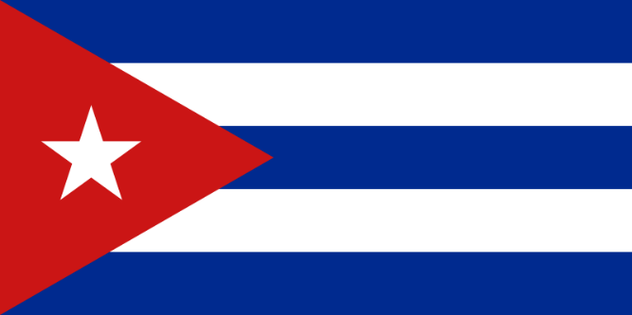**Committee:** Special Political and Decolonization Committee (SPECPOL)

**Topic/ Agenda:** Effects of Foreign Companies on the Economies and Politics of Central American Nations

**Country:** The Republic Of Cuba

**Delegate’s Name:** Muhammet Burak Kaymak

Committed to the principles of sovereignty, self-determination, and economic justice, the Republic of Cuba addresses the critical issue of the influence of foreign corporations on the economies and policies of Central American nations. This stance is rooted in our historic struggle against imperialism and our unwavering solidarity with nations facing similar challenges.

**Historical Context and Current Position**

Central American countries have long been subject to economic and political pressure exerted by foreign companies. Often acting for the purpose of profit maximization, these organizations exploit local resources and labor, generating significant profits for foreign companies while providing minimal economic benefits to host countries. This dynamic has led to significant economic inequalities, political instability, and environmental degradation.

Cuba has been aware of the political stance of private companies since its revolution. The Cuban people, who were exposed to the pressure of the policies implemented by the companies in favor of the USA, opposed this situation and emphasized that local economies should be supported.

Cuba recognizes the negative effects of these external influences and has consistently defended the rights of nations to control their own resources and economies. We believe that sustainable development can only be achieved with policies that prioritize the welfare of local people and protect national sovereignty.

**Current Political Demands**

*Cuba calls for the creation of comprehensive legal frameworks that will limit the political activities of foreign companies and ensure transparency and accountability. These measures should include strict regulations on political contributions and lobbying activities by foreign entities.

*Working together, these countries can develop unified strategies to regulate foreign investment, protect natural resources, and provide equitable economic benefits. Cuba encourages the formation of regional bodies that will coordinate these efforts, share best practices, and represent collective interests in international forums.

*Cuba supports policies that stimulate the growth of small and medium-sized enterprises (SMEs), encourage innovation, and increase the skills and capacities of the local workforce.

**Solution**

In conclusion, the Republic of Cuba reaffirms its determination to support the Central American nations in mitigating the negative effects of foreign companies on their economies and policies. By advocating for stronger regulations, promoting regional cooperation and strengthening local economies, we can collectively work towards a future where sovereignty, equality and sustainable development are supported. Cuba stands ready to cooperate with its Central American neighbors and the international community in this important effort, guided by the principles of the United Nations and our common vision of justice and dignity for all peoples.

**Sincerely, The Delegate Of The Republic Of Cuba Muhammet Burak Kaymak**