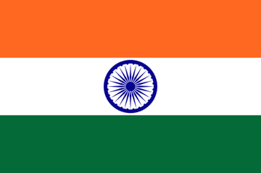**Committee: SOCHUM (Social, Humanitarian & Cultural Committee)**

**Country: India**

**Agenda Item: Preserving Freedom of Press**

In aspect, preserving freedom of press reflect democracy and government’s policy literally. Due to this fact, in some condition, this circumstance could not be promoted by every government. As the consequence, journalists would threaten by corporation. Furthermore, this threat is not demonstrated by government or corporation. Although it also could be by civil citizens, our country inhibits every sort of threats to the press.

In India, there are cases where we have witnessed an increase in restrictive laws, censorship, and practices against freedom of the press and pressures on journalists. This situation weakens our democratic values and establishes a republic of fear in our country. In this context, the protection of freedom of the press is critical for the free expression of ideas and for securing the public's right to information.

Having adopted the United Nations Universal Declaration of Human Rights, which includes freedom of expression and freedom of the press, our country has also accepted the articles on freedom of the press. In this context, the issue of freedom of the press in our country can be examined and criticised in the United Nations Human Rights Council. Freedom of the press can also be included among the issues discussed in the General Assembly of the United Nations. The decisions taken can be put into effect and put into practice. In addition, the United Nations can contribute to our country with technical and co-operation support. Thus, India can benefit from international programmes to strengthen press freedom. In addition, the international standards of the United Nations on press freedom should be internalised, assimilated, and implemented by our country as a social culture. Because the protection of freedom of the press, which is one of the cornerstones of a democratic society, is vital for securing human rights.

**Delegate: Öykü GÖKYER**