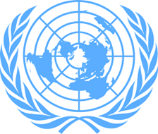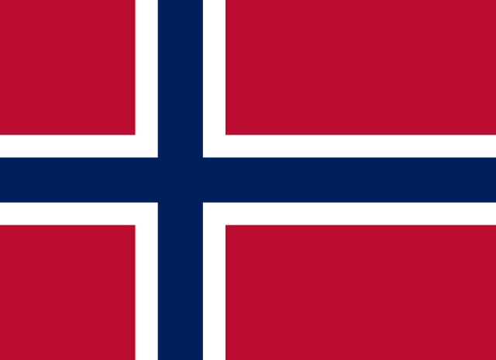Country: Norway

Committee: SOCHUM

Agenda Item: Preserving Freedom of the Press

Delegate: Zeynep DOLMACI

Norway is a country which deeply values the freedom of the press.Reporters Without Borders ranks Norway 1st in its Worldwide Press Freedom Index. Freedom of the press in Norway dates back to the constitution of 1814. Norway believes that making improvements on this topic is crucial.

Norway’s media outlets are not state-run instead they are operated by private companies.

The Norwegian Union of Journalists is the only authorized union in the field of journalism. As of August, it has 9,500 members. The Norwegian Journalists' Union is also the governing body of the Norwegian Press Council, which is in charge of state funding, ethics and punishment in the Norwegian media system.

Norway’s laws and attitude towards jou7rnalists and media creates the atmposhere that has freedom of speech and information. However, global challenges such as the rise of fake news have made the preservation of press freedom more complex and crucial. Norway also realises that preserving freedom of press is a global problem and as the leader of this topic they must support other countries.

To prevent the spread of false information Norway can propose two ideas: having partnerships with social media platforms and tech companies to identify the source of false information and encourage these platforms to prioritize user education about their content and having a double check system before these kind of information is published.

This will reduce the spread of false information on the most used digital platforms and educating users about the content they see online.

To help other countries improve Norway has some solutions too: Fighting against laws that restrict the freedom of the press, supporting countries that are improving on this topic and raising awarness of the harassment of journalists globally.