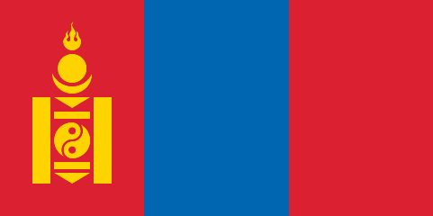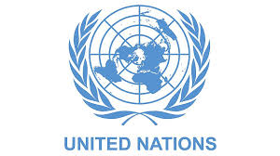**COUNTRY*:* MONGOLİA**

**COMMİTTE: UNİTED NATİONS HUMAN RİGHTS COUNCİL(UNHRC)**

**TOPİC:PRESEVİNG HUMAN RİGHTS OF UYGHUR TURKS**

Mongolia is the world’s largest country that does not have any border to a sea or an ocean. Mongolia borders with the People’s Republic of China and Russia. Mongolia has an area of 1.5 million kilometers square with a population of about 3.4 million people. That makes Mongolia the world’s most sparsely populated sovereign state. Most of the country is covered with mountains and grassy steppe. Ulaanbaatar, the capital of Mongolia, is home to half of the country's population**.**

Mongolia’s economy is often considered as our natural source. Especially mining, for example: coal, copper, gold, and uranium sources has a huge space in the economy of Mongolia. With that economy is often small-shaped and externally dependent. The economy in Mongolia is limited with the facts of the lack of population, the attachment to natural resources, and the geographic location of the country of Mongolia. Life expectancy in Mongolia may show differences according to the part of the country you are living in. The people who live in the big states may have better health, education, and infrastructure services rather than the people who are living in the countryside.

Mongolia supposes that the human rights violations in Xinjiang Uyghur Autonomous Region are a subject the whole World needs to focus on. Mongolia try to make their voices to get heard,. After this time Mongolia requests the help of the UN to shut down the concentration camps in China’s  Autonomous Xinjiang Region, collect the affidavits of victims, and punish every single person starting from the president of the country to the lowest employee no matter if they are female or if they are male who caused this and started this brutal genocide and the violation of the human rights.Mongolia defends that China's actions to “keep away from terrorism” are nothing more than an attempt to brainwash people and make them forget their old identities and convert them into themselves. Mongolia does not wants to allow Uyghur Turks to have their rights violated and to be subjected to genocide any longer. The positive effects of the Uygur Turks are very important in the history of Mongolia. Mongolia considers this subject not only like “brainwashing people” but the economic improvement of China.

***SOURCES:***

[***https://en.wikipedia.org/wiki/Uyghurs***](https://en.wikipedia.org/wiki/Uyghurs)

***<https://en.wikipedia.org/wiki/History_of_the_Uyghur_people>***

[***https://en.wikipedia.org/wiki/Mongolia***](https://en.wikipedia.org/wiki/Mongolia)

[***https://dergipark.org.tr/tr/pub/asyar/issue/47774/601074***](https://dergipark.org.tr/tr/pub/asyar/issue/47774/601074)

[***https://www.britannica.com/place/Xinjiang***](https://www.britannica.com/place/Xinjiang)