Committee Name:the Social, Humanitarian, and Cultural Committee (SOCHUM)

Topic/Agenda: Seeking Solutions for human rights violations derived from ethnic divides.

Country: South Africa

Delegate’s Name: Ecenaz Ozubek

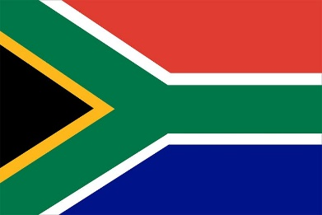

Since the Republic of South Africa was historically a colonial country, it has a great ethnic diversity. The communities living in the country have different traditions and cultures due to their diverse origins. Because of this multiculturalism, the country is called the Rainbow Nation.

For many years, the administration of the country was carried out by the white race, during which time discrimination was applied to blacks and other races. The discrimination against ethnic groups was formalized after the 1948 elections. The Apartheid system, which was supported by laws since 1958, facilitated racist practices such as classifying people according to their origins, resulting in non-white minorities benefiting less from citizenship services and social programs provided by the state.

Today, a new constitution signed by Nelson Mandela has been put into effect, ending the Apartheid system. Although racism has decreased in today's South Africa, it still continues. Anti-racism parties have been established to address this issue. However, racism still persists both within the country and outside. Societies must be educated to prevent racism.