Committee: Disarmament and International Security Committee (DISEC)

Topic: Reduction and Elimination of Nuclear Arms and Weapons

Delegate: New Zealand

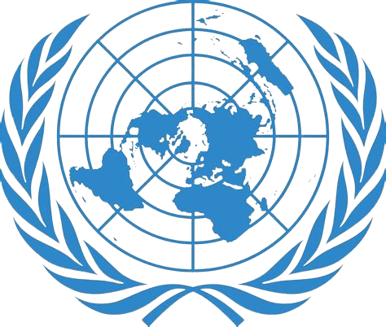

Introduction:

New Zealand is deeply concerned about the devastating consequences of nuclear weapons and their potential to cause catastrophic harm to human life, the environment, and global stability. As a nation committed to disarmament and international security, we strongly believe that the elimination of nuclear arms and weapons is essential for a safer and more peaceful world.

Country Position:

New Zealand is firmly opposed to the possession, development, and proliferation of nuclear weapons. We recognize that these weapons of mass destruction pose an existential threat to humanity and undermine global efforts to promote peace, security, and sustainable development.

Reasons for Our Position:

Humanitarian Concerns: The use of nuclear weapons would have catastrophic humanitarian consequences, including massive loss of life, long-term environmental damage, and displacement of people.

International Security: The proliferation of nuclear weapons increases the risk of nuclear conflict, which would have devastating consequences for global security and stability.

Disarmament Obligations: New Zealand is committed to fulfilling its obligations under the Treaty on the Non-Proliferation of Nuclear Weapons (NPT) and the Comprehensive Nuclear-Test-Ban Treaty (CTBT).

Proposed Solutions:

Total Elimination: New Zealand calls for the total elimination of nuclear arms and weapons, with a commitment to achieving a nuclear-weapon-free world.

Disarmament Verification: We propose the establishment of a verification mechanism to ensure the irreversible disarmament of nuclear weapons and their production facilities.

International Cooperation: New Zealand urges all nations to engage in constructive dialogue and cooperation to address the challenges posed by nuclear weapons and to work towards a nuclear-weapon-free world.

Conclusion:

New Zealand is committed to playing an active role in promoting disarmament and international security. We believe that the elimination of nuclear arms and weapons is a critical step towards achieving a safer, more peaceful, and prosperous world for all. We look forward to working with fellow delegates to find common ground and solutions to this pressing global challenge.