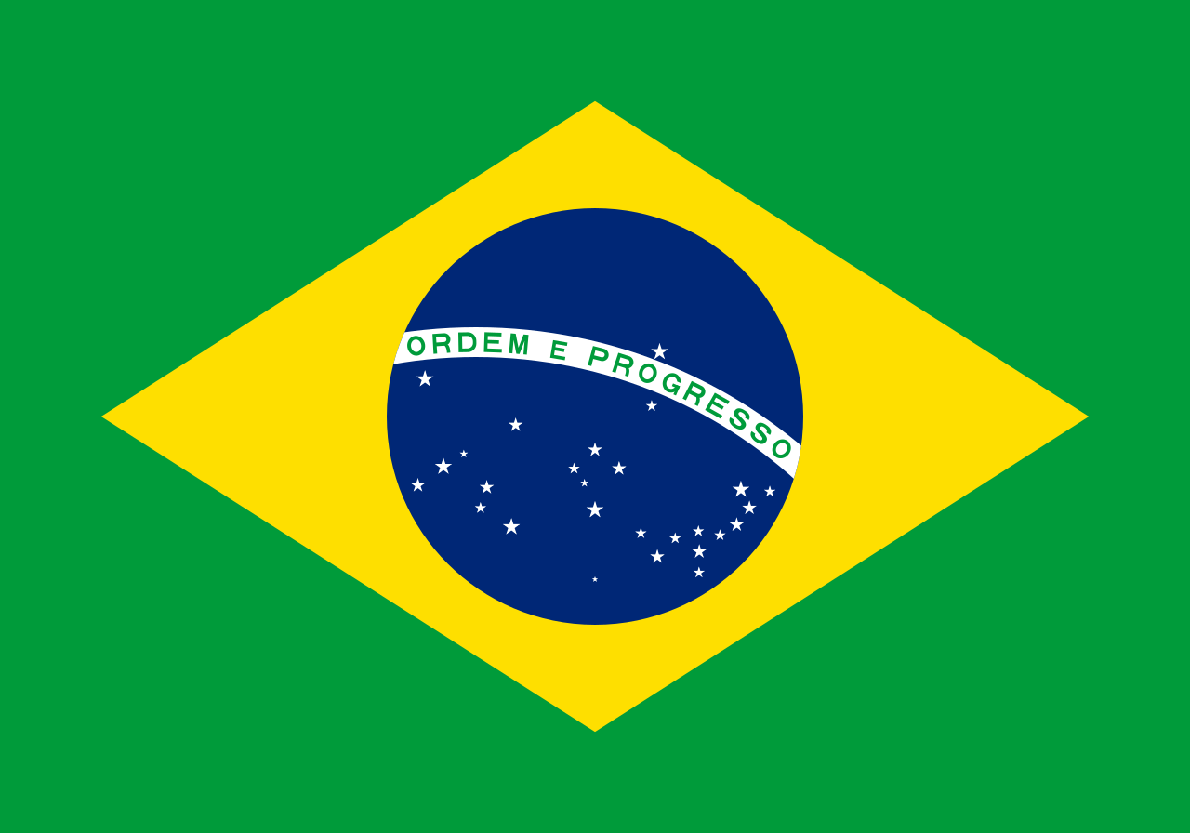

DELEGATE: Selin Baş

COUNTRY: Brazil

COMMITTEE: Social, Humanitarian & Cultural Issues (SOCHUM)

ISSUE: The Freedom of Press in Brazil

SOCHUM aims to raise awareness to issues of countries as human rights questions. Its topics are important because they affect human lives so closely. It was founded in 1945 as a reaction to the establishment of the Universal Declaration on Human Rights.

Today, we want to discuss the freedom of Press in Brazil. Our media landscape is marked by a high concentration of private sector media ownership, characterised by a near-incestuous relationship between centres of political, economic and religious power and influence. Structural violence against journalists, highly concentrated media ownership, and the effects of disinformation still pose major challenges for press freedom. In addition there are some precaution taken but it is all framework so they are not efficient. Reporters and the media are often subjected to abusive lawsuits by politicians and business interests, who use their influence to intimidate the press. The local press is increasingly weakened and online media outlets are experiencing viability problems. The aggressive rhetoric toward journalists and the press adopted by the Bolsonaro administration from 2019 to 2022 fuelled an increasingly hostile and distrustful attitude towards journalists within Brazilian society. During the past decade, at least 30 journalists have been killed, the region’s second deadliest country for reporters during that period. Most vulnerable are bloggers, radio hosts and independent journalists working in small- and medium-sized municipalities, covering corruption and local politics. Online harassment and attacks on journalists, especially women, are on the rise. At least three murders were directly linked to journalism in 2022, including the murder of British reporter Dom Phillips while he was investigating environmental crimes against indigenous communities in the Amazon. For journalist and writer Cora Rónai, “the biggest difference of all is that we have a human being in the presidency, something that could not be said of Bolsonaro”.

There are some notable improvements since the 1984 direct elections until the first election of Lula in 2002. Like gradual and wider commitments to equilibrium in political reporting during election campaigns, restructuring of key media industries, such as the newspapers *O Globo* and the *Folha de São Paulo,* in order to better attend to multiple post-dictatorship publics. Many Brazilian academics have underscored how the country has advanced less in media reform than its Latin American counterparts.

Therefore arguments about the *capacity* for a stronger public media in Brazil to be an instrument of media independence and freedom from both political and economic constraints. We are pursuing a legitimate path of democratizing knowledge by creating the means to strengthen public debate, providing the means of improving educational levels and investing in high quality programming and information capable of boosting cultural emancipation and diversity. In this sense, they are paving the way for wider social, cultural and economic equality for future generations in Brazil. The laws should be reconsidered and adapted to modern life.

Resources:

* <https://rsf.org/en/country/brazil>
* <https://www.researchgate.net/publication/258130692_Media_Democratization_in_Brazil_Achievements_and_Future_Challenges>
* <https://www.google.com/url?sa=t&source=web&rct=j&opi=89978449&url=https://www.westminsterpapers.org/article/160/galley/3582/download/&ved=2ahUKEwjY_Nf2ou2FAxX_BdsEHVdSC5AQFnoECBAQAQ&usg=AOvVaw0_kv1e5fkvTNoQrVYJSW4P>