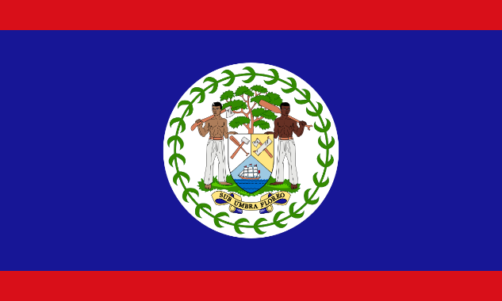Committee: SPECPOL

Country: Belize

Agenda Item: Effects of Foreign Companies on the Economies and Politics of Central American Nations

Introduction

“Belize is pleased to be able to speak for the Special Political and Decolonization Committee today regarding the vital issue of foreign businesses influence over Central American nation economies and politics. Being a nation at the core of one among the regions, Belize knows about the complex mechanics and issues influencing outside speculations. This position paper is intended to clarify the Belizean opinion on this important matter, and recommends how best to continue while ensuring sustainable development and conservation of national sovereignty.

Economic Impact

International corporations also have an impact on the economic environment in Central America. While such investments have the potential to generate jobs, help develop infrastructure and increase technology access in the host country, Belize is worried about some of the possible negatives for instance;

Economic Dependency: Reliance on international corporations for employment and investment has the potential to create a situation in which Central American nations are susceptible to external shocks, including capital withdrawal. Evidently, if these corporations pull out or downsize their operations will result in a massive economic depression and unemployment levels.

International corporations may obtain huge profits, nonetheless; they fail to appropriately distribute wealth within the host country (Jain 451). ll of this can widen income inequality, with the gains receding to headquarters someplace or a small slice of society reaping all the rewards. Left behind are underprivileged communities and regions that miss out on economic possibilities.

Thus, to summarize, although international corporations bring economic possibilities to Central America, Belize is well aware of the potential negative impacts/side-effects. In addressing concerns of economic dependency, unequal wealth distribution, environmental degradation, labor exploitation and tax evasion and undermining small local businesses. Belize is campaigning to take pre-emptive steps with clear-cut regulations, stringent enforcement and stakeholder involvement in an effort to allow sustainable and fair development. If countries in Central American achieve responsible business conduct, and prioritize community well-being they can take advantages of investment from other places in their country without comprising their own sovereignty as well killing people. Governments, corporations civil society and communities must increasingly work together to build back better by creating inclusive and resilient economies throughout the region