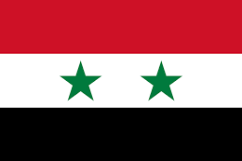

**Country:** Syrian Arab Republic

**Committee:** LEGAL

**Agenda Item:** The question of legal framework for the Prisoners of War (POW) and its safe conduct regarding their protection during war times

Syrian Arab Republic is located in the Eastern Mediterranean, it has boundries to Türkiye, Iraq, Jordan, Lebanon and Israel and is a unitary republic which is formed by 14 subdivisions. Syria consists of different ethnicities such as Kurds, Armenians, Albanians and majority of them are Arabs. The largest city which is also the capital city is Damascus. The largest religious group are Sunni Muslims. Syria gained its’ independence on 24 October 1945 by ending the French mandate and became a founding member of United Nations.

The Geneva Convention that we are not a part of protects and set rules in the benefit of prisoners as well as giving them rights. Syria recognizes the effort that countries have put in the convention as well as keeping in mind of the condition of nearly a hundred years ago. As a non-member of the convention Syria despises those who act against it. Approving the actions that the United Nations Security Council took such as ensuring the states that are a member to follow regulations which were taken in the Fourth Geneva convention and also providing jurisdiction of those who violete these laws.

Syria realizes the importance of the acceptance of the Geneva Convention and wishes for further action to be taken according to the issue. Having studied the death rate of war prisoners we are fully alarmed of the situation as we seek for collobration between nations for peace.