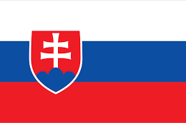**Country:** Slovak Republic

**Committee:** North Atlantic Treaty Organization

**Agenda item:** Ratification of Sweden’s NATO Membership in Fostering Cooperation and Partnership between Partner States

The North Atlantic Treaty Organisation is the result of a multination peace, security and justice agreement in 1949 under the leadership of the United States through gathering several North Atlantic Region countries. Since then NATO has been working in order to keep up to its essential purpose as well as focusing on issues as ensuring global security and adapting to changing security and military implications.

Following the end of the Soviet Union in 1991 former Warsaw Pact and Post Soviet States started to join NATO through numerous debates within NATO. NATO then made official rules for states who would want to join which is called “Membership Action Plans(MAP)” this aided many members to enter. The Slovak Republic is one of these members and has been a member state of NATO since 29th of March 2004. Even though NATO has an “open door” policy meaning parties can invite other states these invitees should fulfil at least 5 criterias in order to enter.

Sweden has been collabrating with NATO since 1944 through various diplomatic relationships such as but not limited to Partnership for Peace programme(PfP)(1994) and the Euro Atlantic Partnership Council(1997). Sweden being an “Enhanced Opportunity Partner” aided its official application in order to join as an ally on May 18 2022 alongside Finland after Russia’s military incusion into Ukraine which took place in February 2022. Sweden’s path into becoming a member of NATO includes obvious advancements and Slovakia appreciates its efforts. As a member state of NATO we belive cooperation is highly essential in between both member and unmember states in order to maintain world peace.